RouterStatus
Administrator Manual
Unified Router Fleet Management
Version 1.2 · July 2026

Table of Contents

1. Introduction
RouterStatus is a unified dashboard for managing a multi-vendor router fleet from a single place. It connects to each router vendor's cloud-management platform through that vendor's API, pulls every device into one inventory, and continuously tracks status, firmware, renewals, and security (CVE) exposure across the entire fleet.
This manual covers everything an administrator needs: navigating the dashboard, using the AI-powered fleet insights and reporting tools, adding and managing vendor integrations (including exactly where to obtain each vendor's API credentials), configuring account and site settings, managing users, and using the platform-level Admin Panel.

1.1 User roles
RouterStatus uses three roles. The features available to you depend on your role.
Field | What to enter
User | Views the dashboard and devices for the groups they are granted access to. Cannot manage integrations, users, or platform settings.
Admin | Full control of their organization (tenant): manages integrations, users, preferences, activity logs, and white-label site branding.
Super Admin | Everything an Admin can do, plus the Admin Panel: global system configuration, tenant management, and cross-tenant user and activity oversight.

1.2 Logging in
Administrators sign in at the application login page. RouterStatus supports email-and-password sign-in as well as single sign-on (SSO) with Google, Microsoft, and Apple. During the current beta, new self-service account creation is disabled; accounts are provisioned by invitation (see Section 6.4).

2. The Dashboard
The dashboard is the home screen. The green header bar holds the Sync Now button (pulls the latest data from every connected platform on demand), a dark/light mode toggle, the Settings gear, and Logout. Below it are the filter/view controls, a row of summary statistics, the CVE security banner, and the device inventory.

2.1 Summary statistics and views
Five cards summarize the fleet at a glance: Total Devices, Online, Offline, Unknown, and Firmware Not Current. You can view the inventory three ways using the Map / List / AI toggle (the AI view is its own section, covered in Section 3), and choose a saved column layout with the view selector (for example, Full). Clicking the Firmware Not Current card applies a quick filter chip above the device list so you can jump straight to those devices.
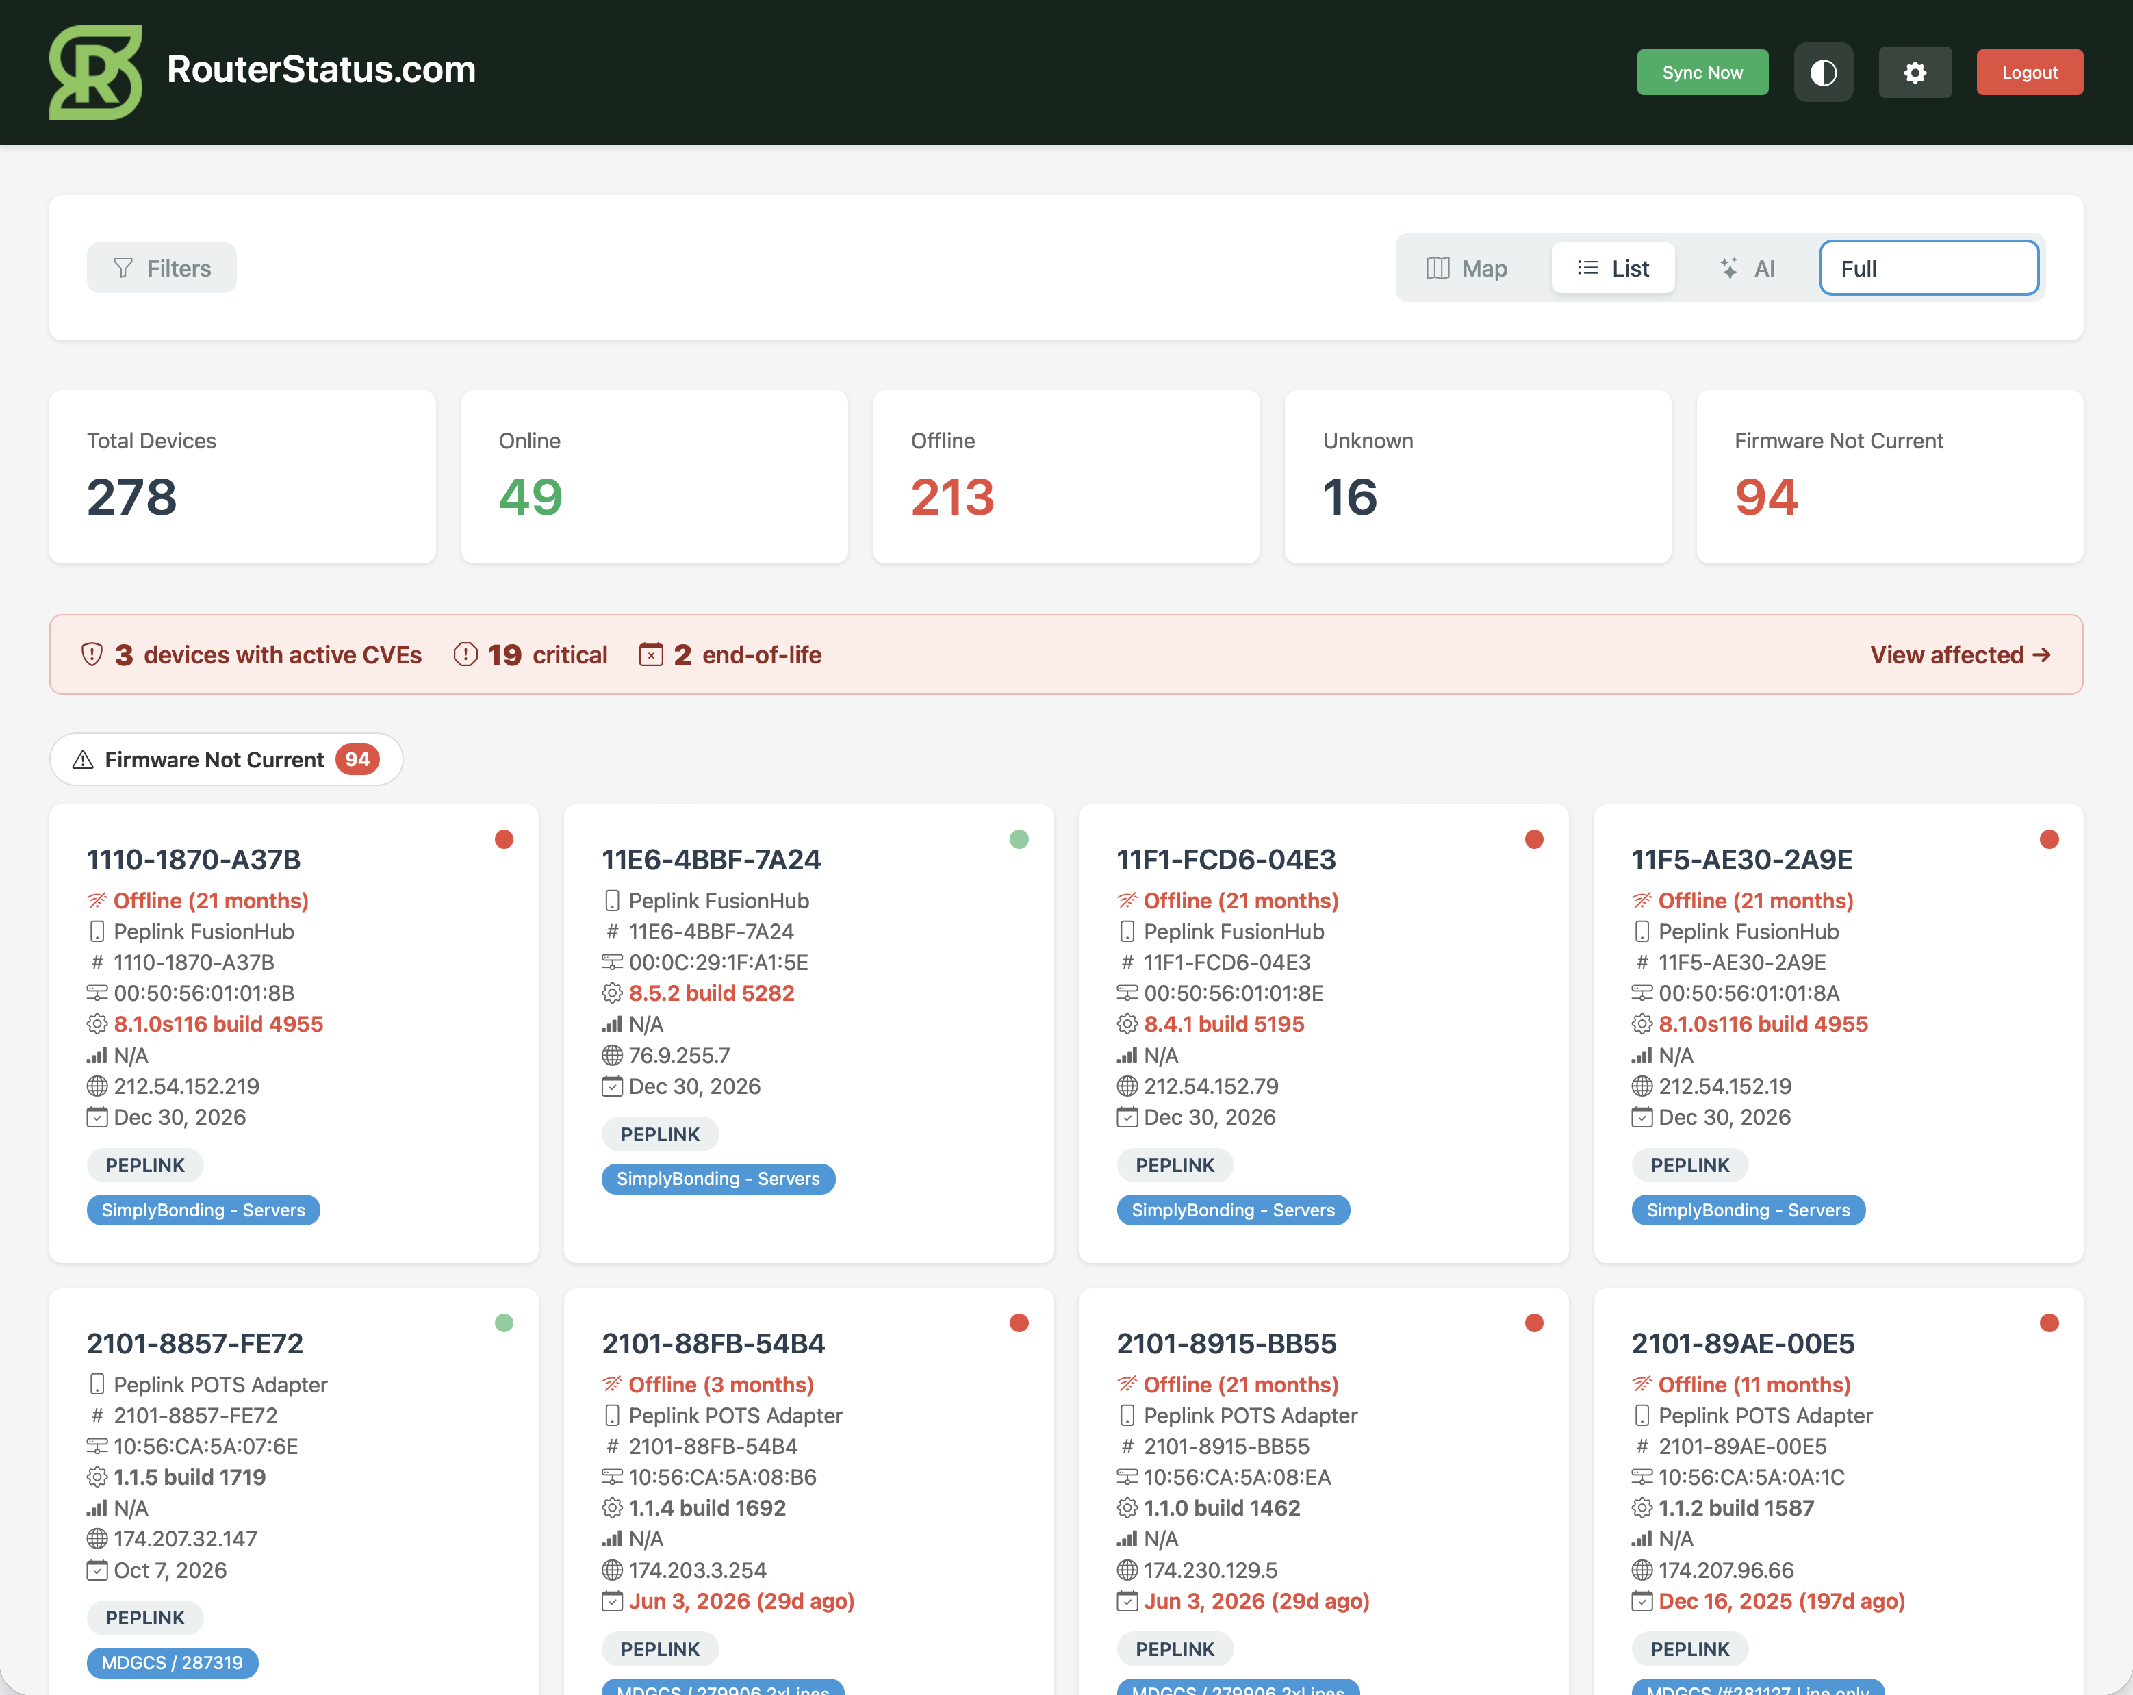
Figure: Dashboard in List view, with the Filters panel open (filtered to Online devices).
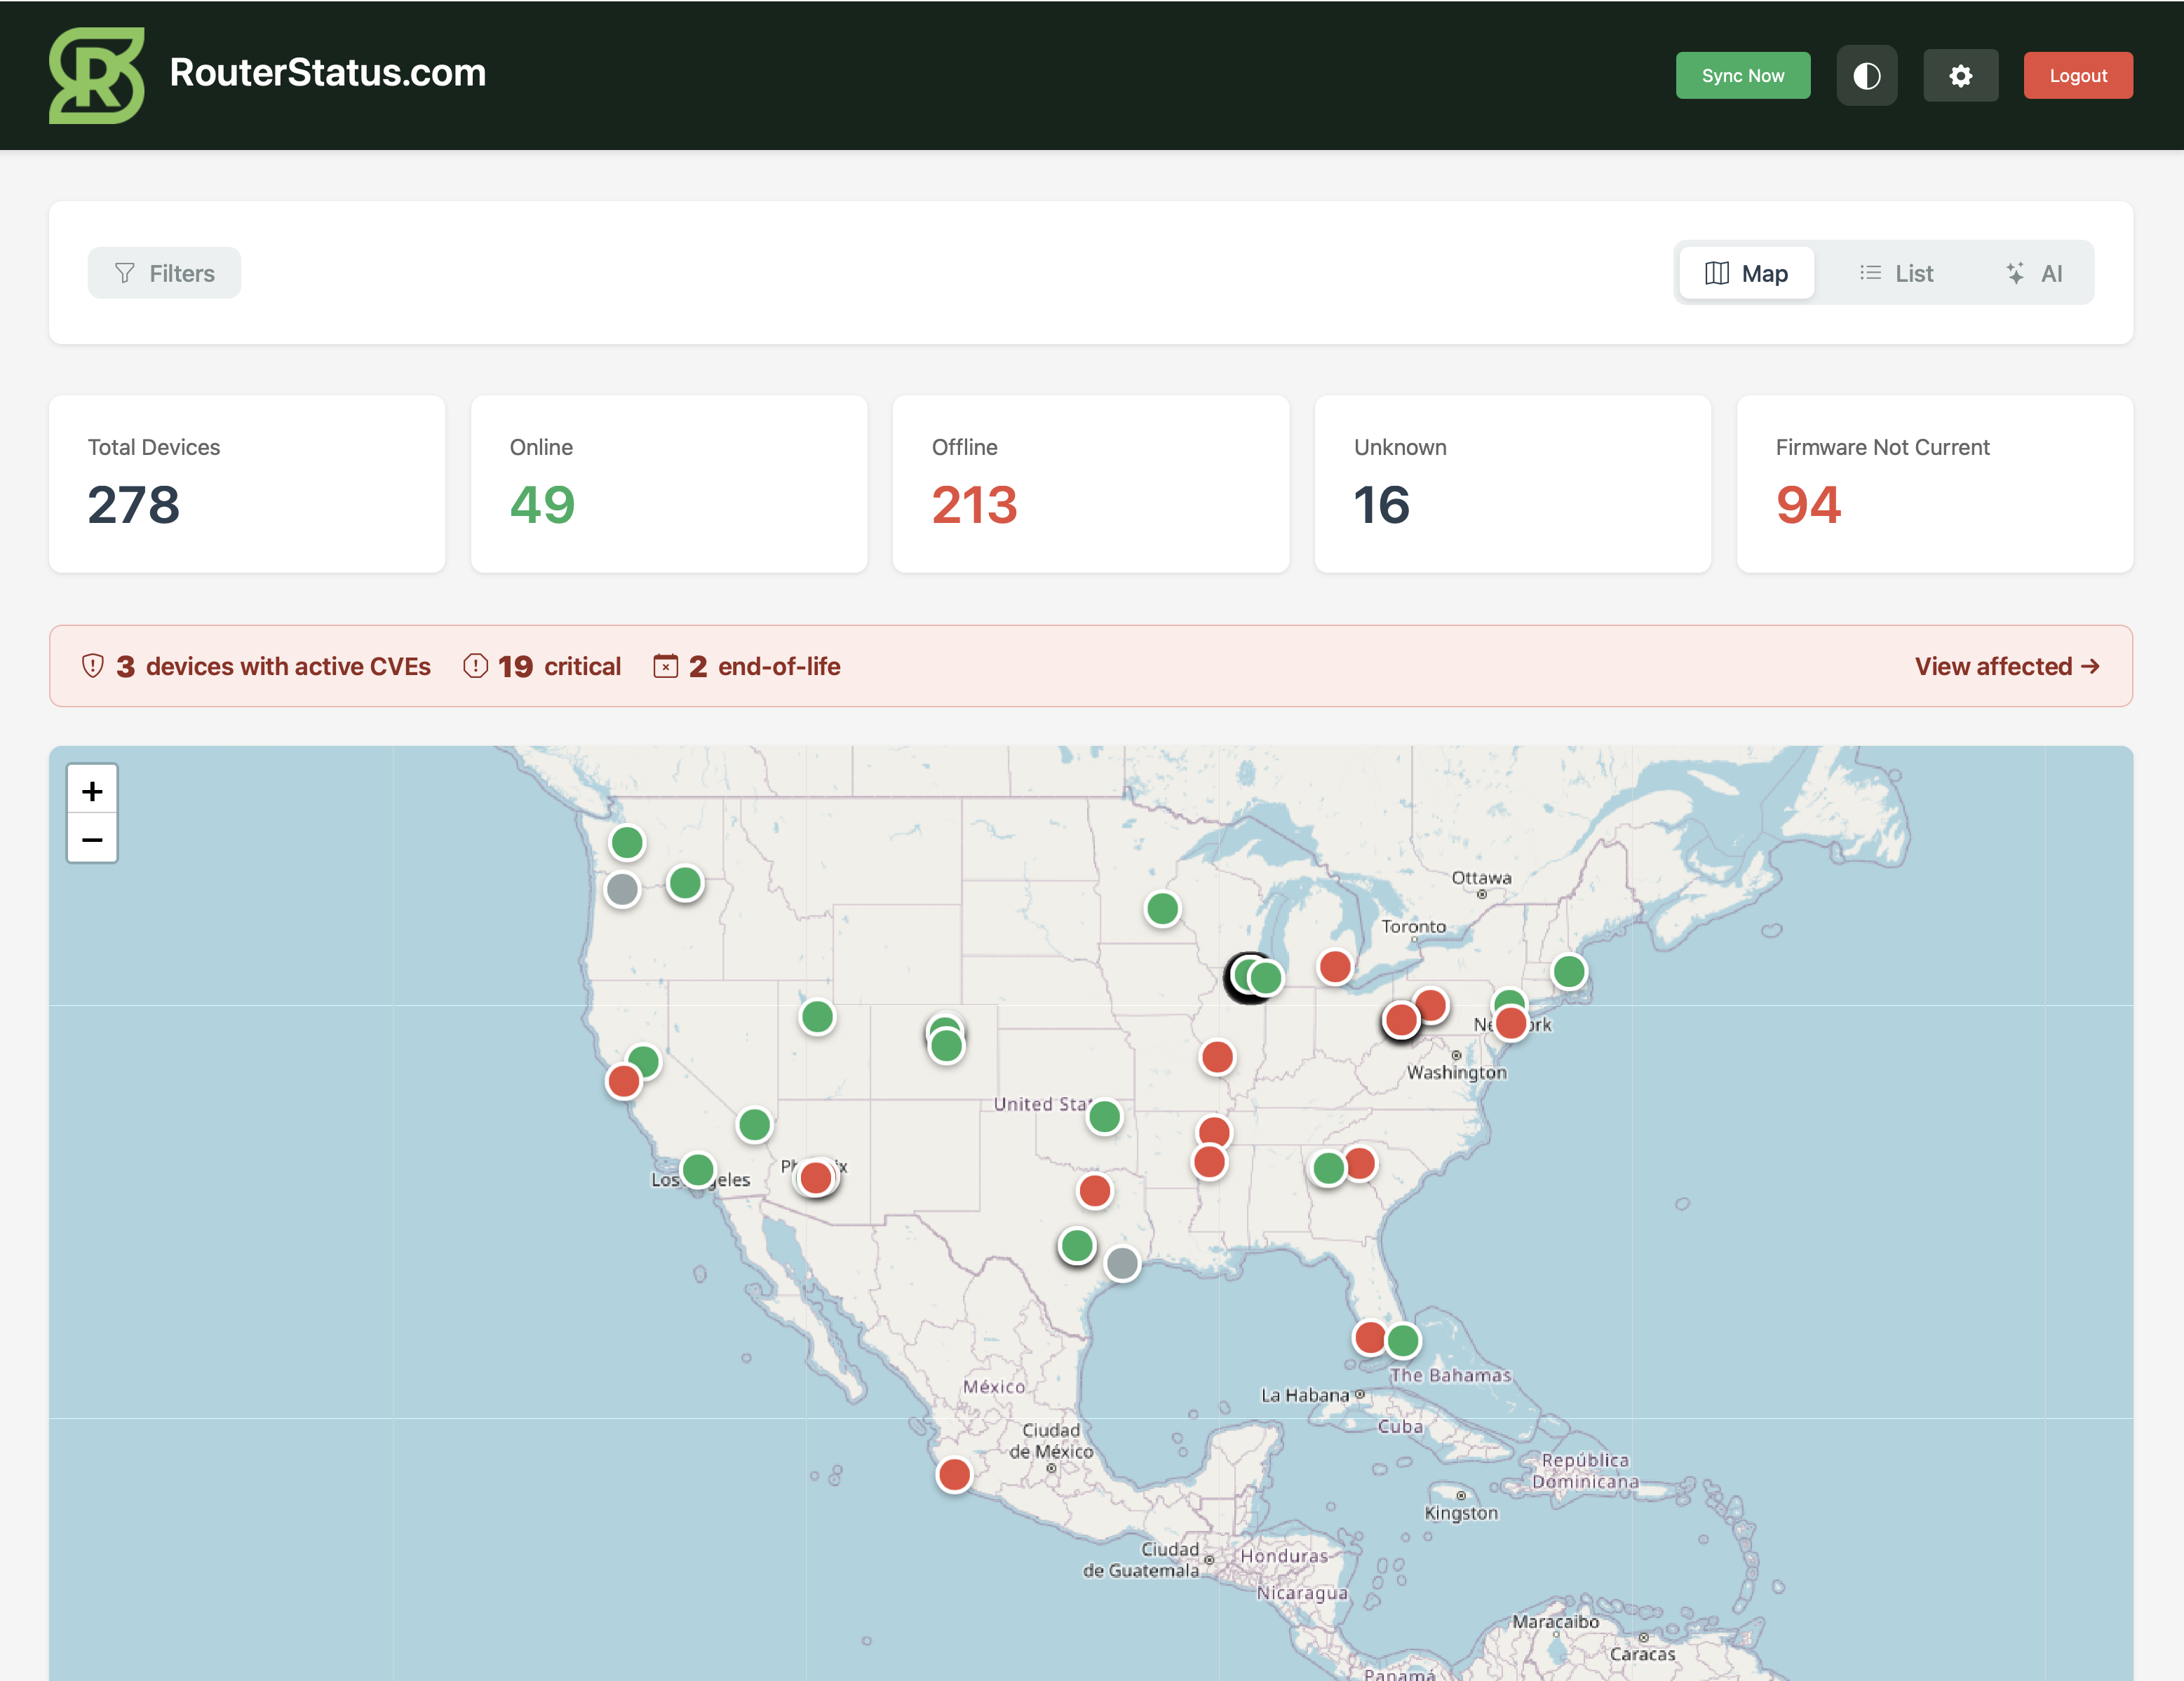
Figure: Map view, plotting each device by location. Marker color reflects status: green = online, red = offline, gray = unknown.

2.2 Filtering and searching
Click Filters to open the filter bar. The filters work together: each one you set narrows the inventory further, and the summary statistics and CVE banner update to reflect only the devices currently shown. To clear a filter, set its dropdown back to the "All" option or empty its text box.
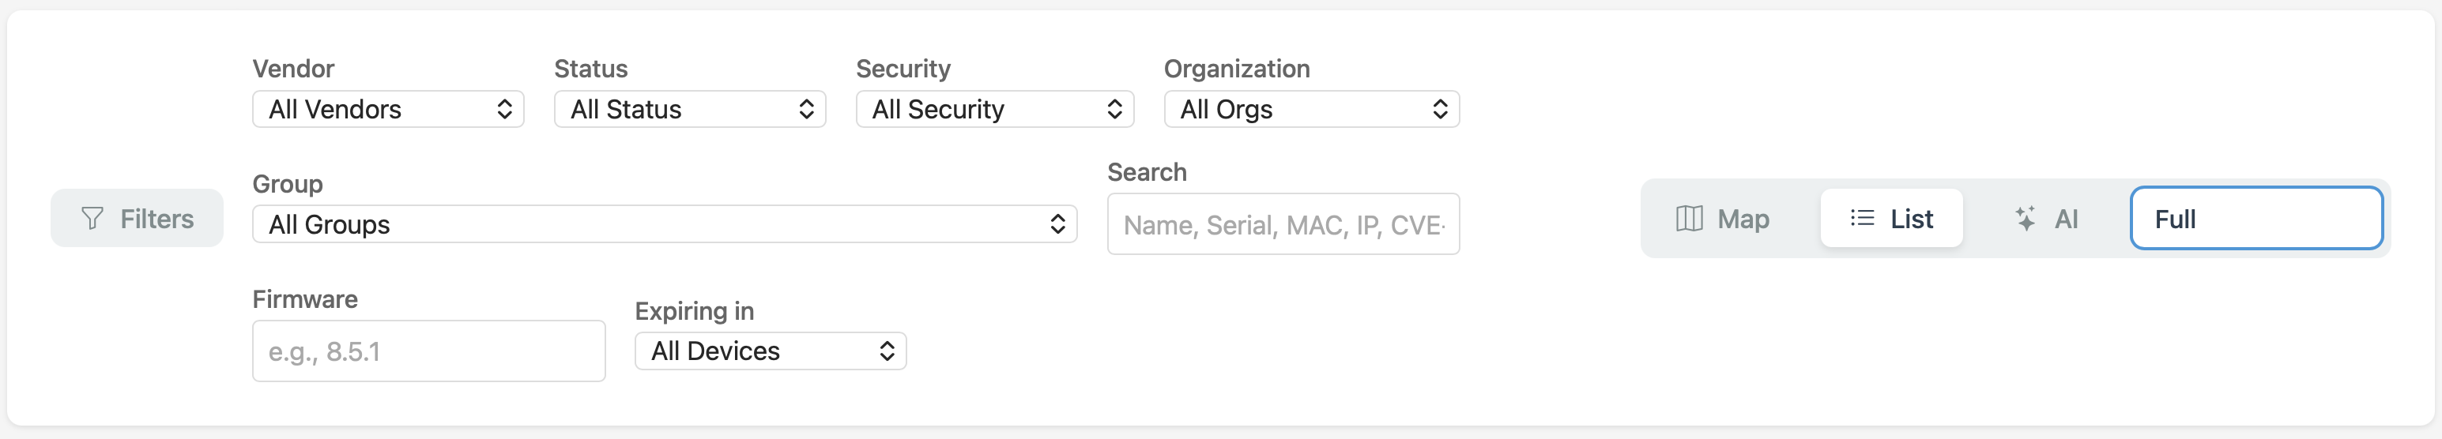
Figure: The Filters bar: Vendor, Status, Security, Group, Search, Firmware, and Expiring in.
The table below lists every filter and its options. Which filters appear on your dashboard can be turned on or off under Settings, Preferences (Section 6.2).
Filter | Options and behavior
Vendor | All Vendors, CradlePoint, Peplink, Digi, Inseego, Teltonika. Shows only devices pulled from the selected platform.
Status | All Status, Online, Offline, Unknown. Filters by the device's current connectivity.
Security | All Security, Has CVEs, Critical only, End-of-life, Firmware outdated, Secure. Filters by the device's security posture.
Organization | All Orgs, plus every distinct organization/account synced from your platforms. Select one to scope the entire dashboard, including the AI view, to just that organization.
Group | All Groups, plus every device group synced from your platforms (each shown with its device count, including nested sub-groups). Select one to show only that group's devices.
Search | A free-text box. Matches a device by name, serial number, MAC address, or IP address.
Firmware | A free-text box. Matches devices whose firmware version contains what you type (for example, 8.5.1).
Expiring in | All Devices, Expired, 30 days, 60 days, 3 months, 6 months, 1 year. Shows devices whose subscription/license expires within the selected window (or is already expired).

Each dropdown is shown below.
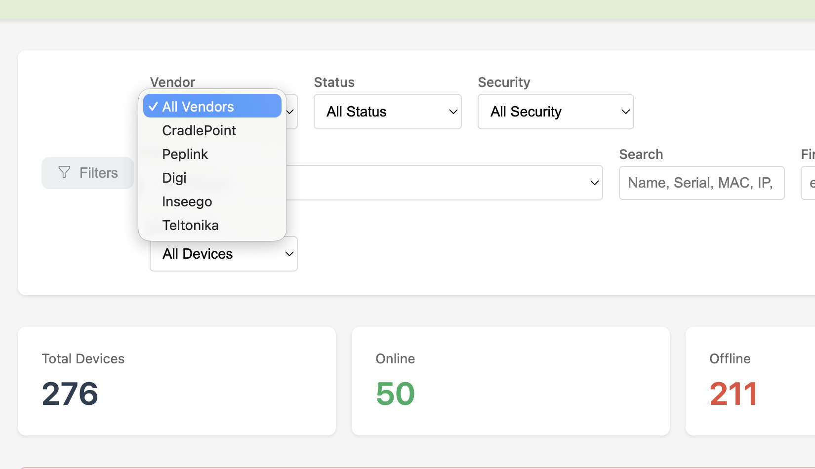
Figure: Vendor filter: filter the fleet to a single router platform.
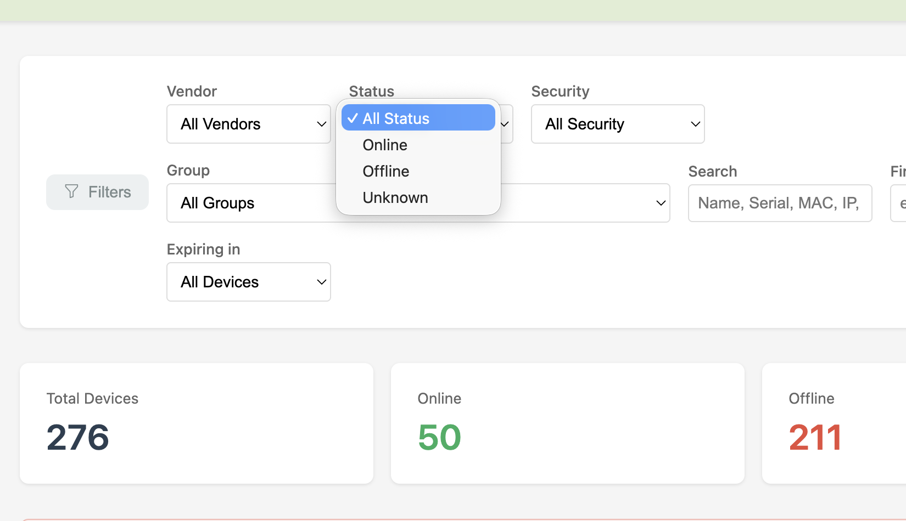
Figure: Status filter: Online, Offline, or Unknown.
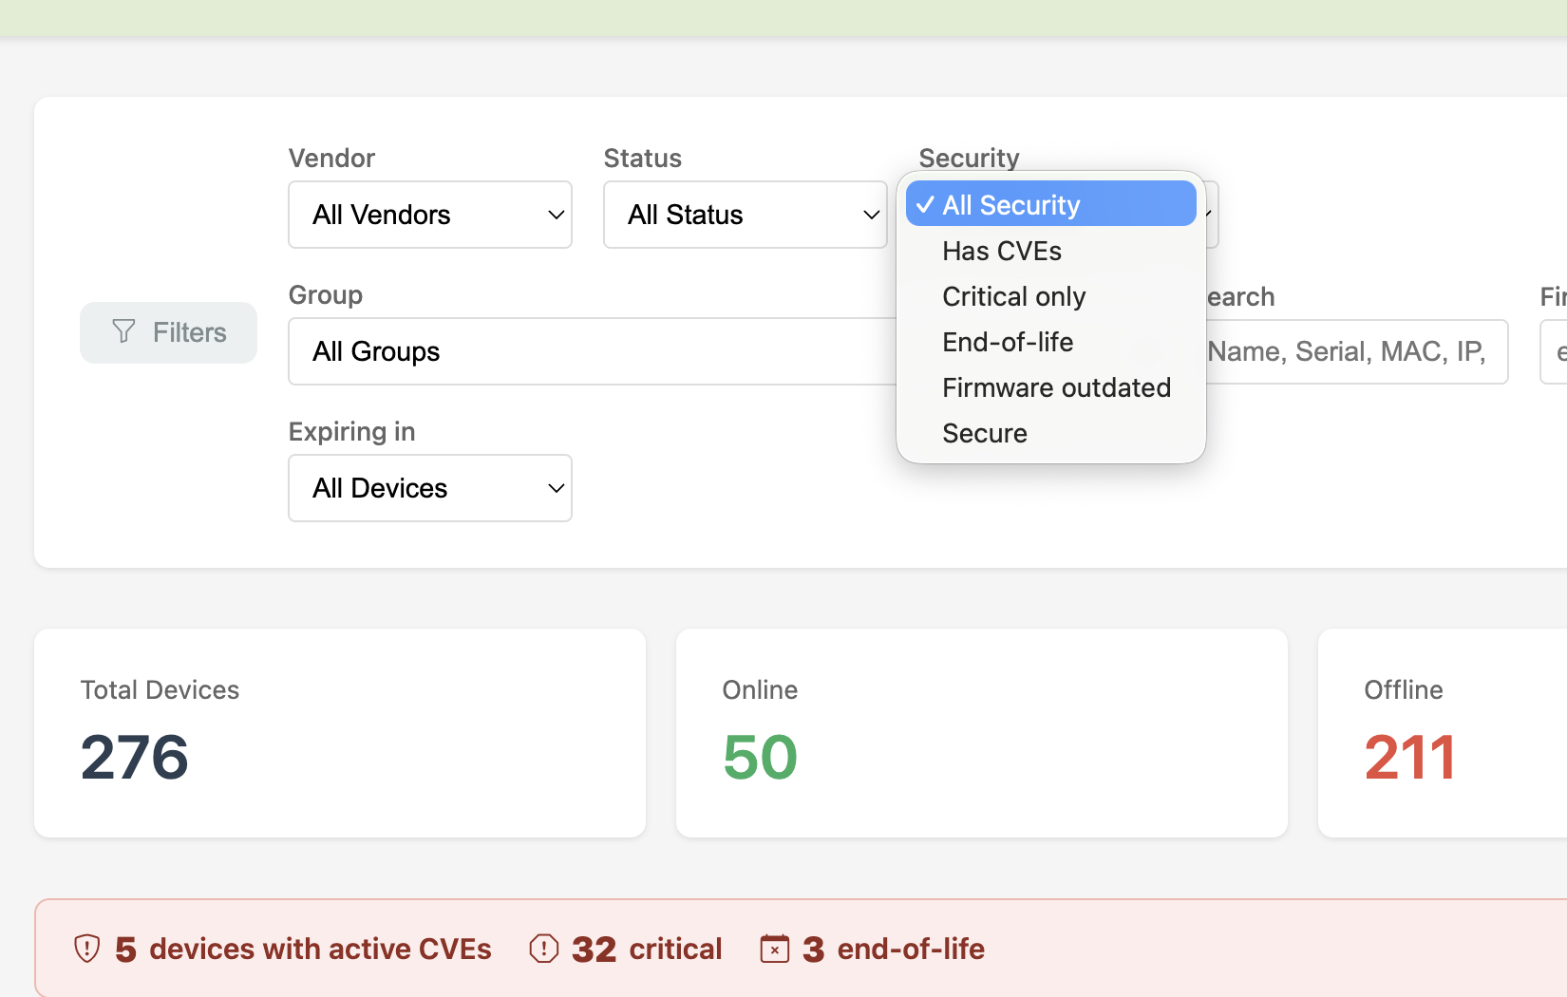
Figure: Security filter: isolate devices with CVEs, Critical CVEs, End-of-life, outdated firmware, or fully Secure devices.
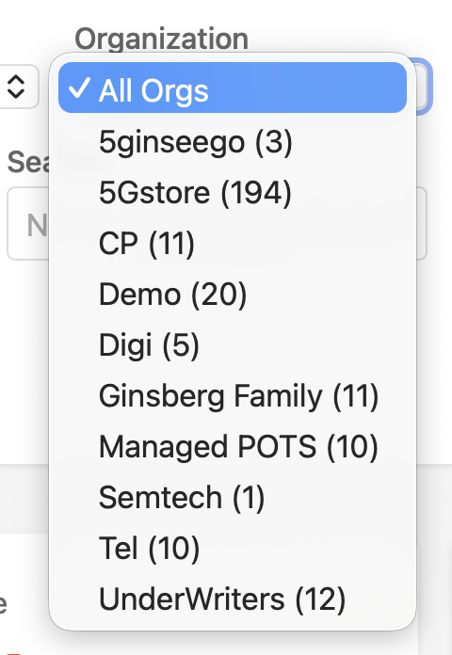
Figure: Organization filter: scope the dashboard to a single synced organization or account.
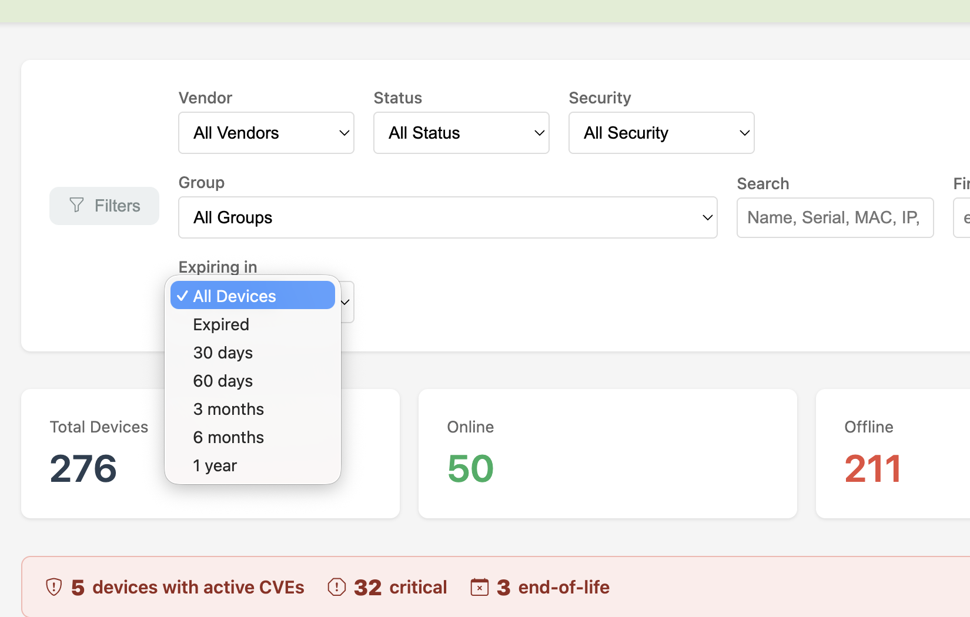
Figure: Expiring in filter: find devices by subscription/license expiration window.
Note: The Group dropdown also lists every group and sub-group synced from your connected platforms, each with a live device count, so you can scope the view to a single site, customer, or team. Organization and Group are independent filters and can be combined.

2.3 Device details
Click any device card (or map marker) to open its detail window: status, vendor, model, serial number, MAC address, firmware version, IP address, signal, carrier, last-seen time, and subscription expiration. A button opens the device directly in its native vendor portal.
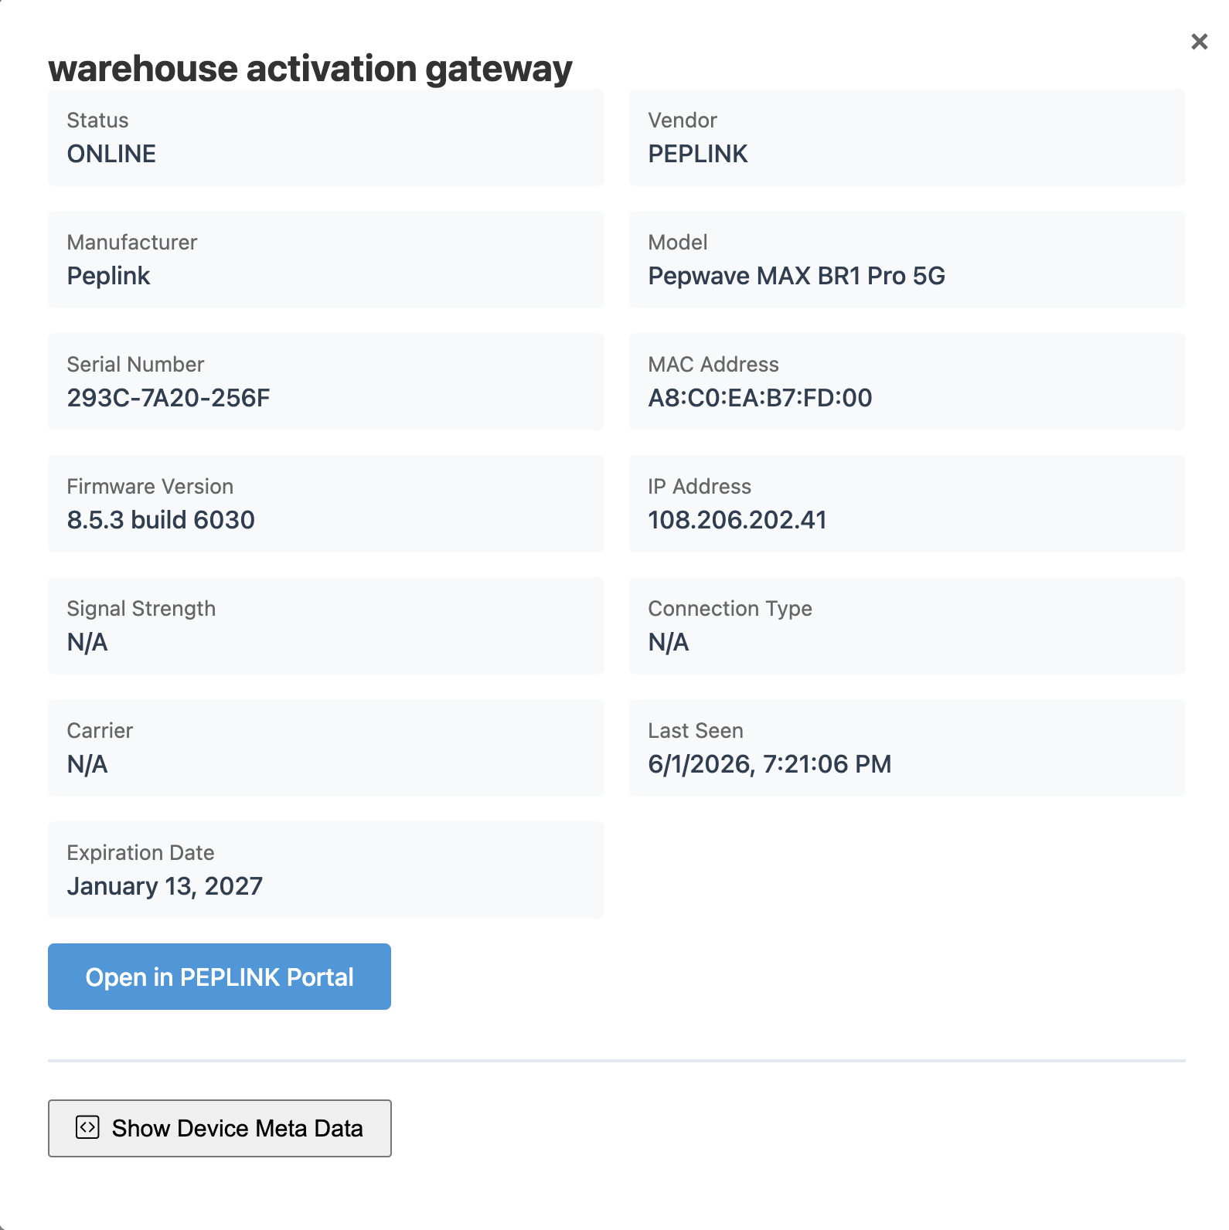
Figure: The device detail window, with a shortcut to open the device in its vendor portal.
If enabled for your role (Section 6.5), a Show Device Meta Data button reveals the raw device record (JSON) for troubleshooting.

3. AI Fleet Insights
The AI view analyzes your entire fleet, whatever vendors it spans, and turns it into a single, plain-English briefing plus a set of focused panels instead of a wall of tables. It is available from the dashboard's AI tab, and respects whatever Vendor, Group, or Organization filters are set above it.

3.1 Fleet health score and briefing
The Fleet briefing card gives your fleet an overall health score from 0 to 100, with a short trend indicator showing whether the fleet is improving or getting worse. Below the score, a plain-English briefing paragraph summarizes what actually needs attention right now, followed by a prioritized list of recommended actions ranked by real risk, not just alphabetically or by device name.
The underlying numbers, firmware currency versus the latest known release, CVE and end-of-life exposure, subscription expirations, and device stability, are computed deterministically from your fleet data. Only the written summary itself is generated by AI, so the score and action list stay consistent even if you refresh the briefing wording.
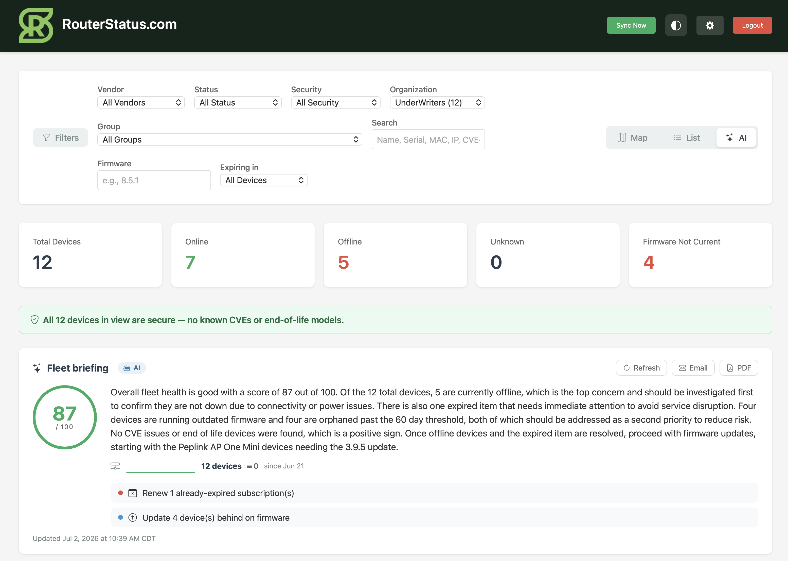
Figure: The Fleet briefing card: health score, trend, plain-English summary, and prioritized action list.
Note: Click Refresh on the briefing card at any time to recompute it against the fleet's current state.

3.2 Top risk devices
A fix-first queue that fuses CVEs, firmware lag, end-of-life status, instability, weak signal, and expiring subscriptions into a single risk score per device, then ranks the whole fleet by it. Each row shows the score, the device, and the specific reason it's flagged (for example, Firmware behind, Subscription expired, or Currently offline), so you always know what to fix first and why.
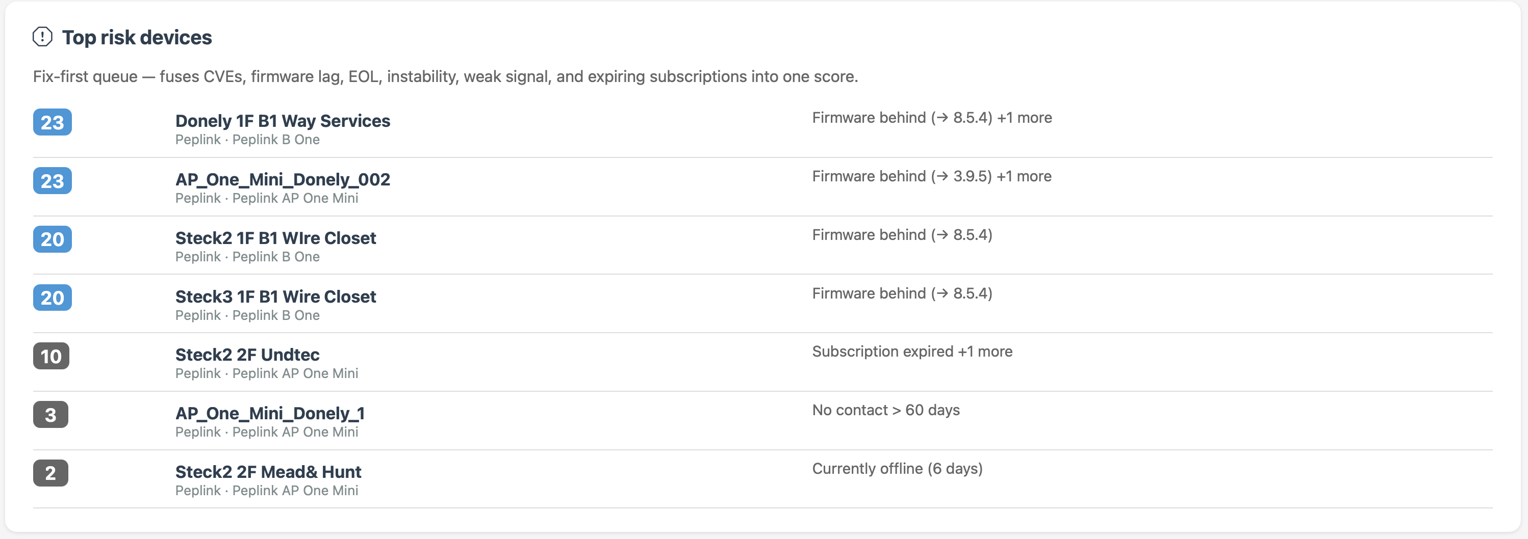
Figure: Top risk devices: a fix-first queue ranked by a combined risk score, with the reason for each device's score.

3.3 Orphaned devices
Devices that RouterStatus hasn't heard from in over 60 days, likely decommissioned, swapped out, or stuck offline. Each entry shows how long it's been since last contact and the last-seen date, so you can decide whether to investigate, remove, or leave it as-is.
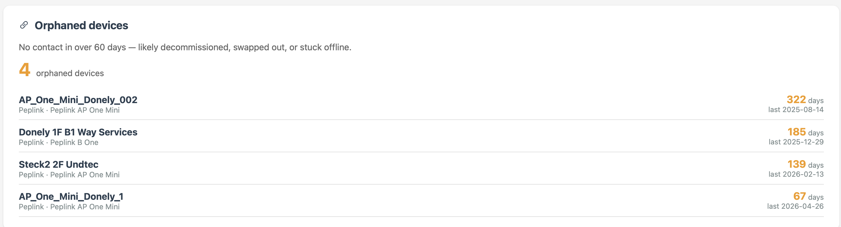
Figure: Orphaned devices: no contact in over 60 days, with days since last contact.

3.4 CVE exposure by manufacturer
A per-vendor breakdown of active CVE exposure across the fleet. Vendors with no known vulnerabilities show a Clear badge; vendors with active vulnerabilities show a Critical badge along with a count of critical and high-severity CVEs and how many devices are affected.
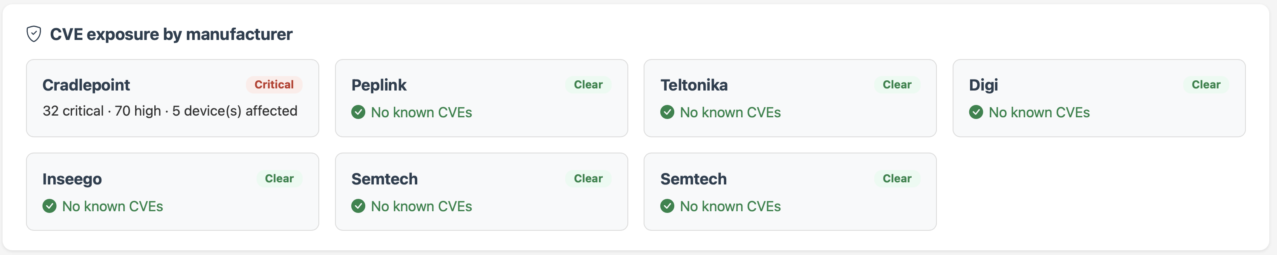
Figure: CVE exposure by manufacturer: per-vendor Clear or Critical status with critical/high counts and affected device totals.

3.5 Early warning: unstable devices
Surfaces devices that are flapping online and offline rather than staying reliably connected. Because flapping devices often go fully dark shortly after, this panel is meant to catch problems before they become full outages. Each entry shows the number of status changes, how many flaps occurred in the last 7 days, and current status.
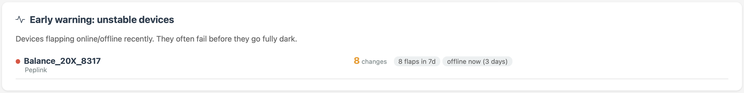
Figure: Early warning: unstable devices, showing recent flap counts for devices at risk of going fully offline.

3.6 Subscription expiration forecast
Summarizes how many subscriptions are already expired or expiring within 30, 60, or 90 days, and charts the expected expirations month by month so renewals can be planned ahead of time instead of discovered after the fact.
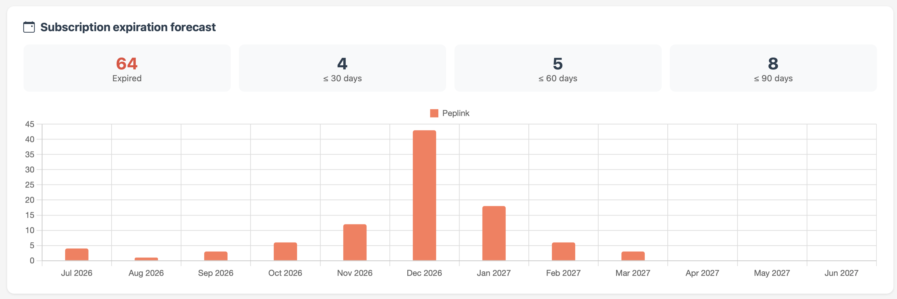
Figure: Subscription expiration forecast: expired/30/60/90-day counts and a month-by-month forecast chart.

3.7 Firmware lifecycle
Four panels on the AI view track firmware across the whole fleet over time, not just a device-by-device snapshot.
Firmware by manufacturer. Every model RouterStatus has seen for a vendor, broken down by the exact firmware version each device is running, with a running count behind the catalog's latest release.
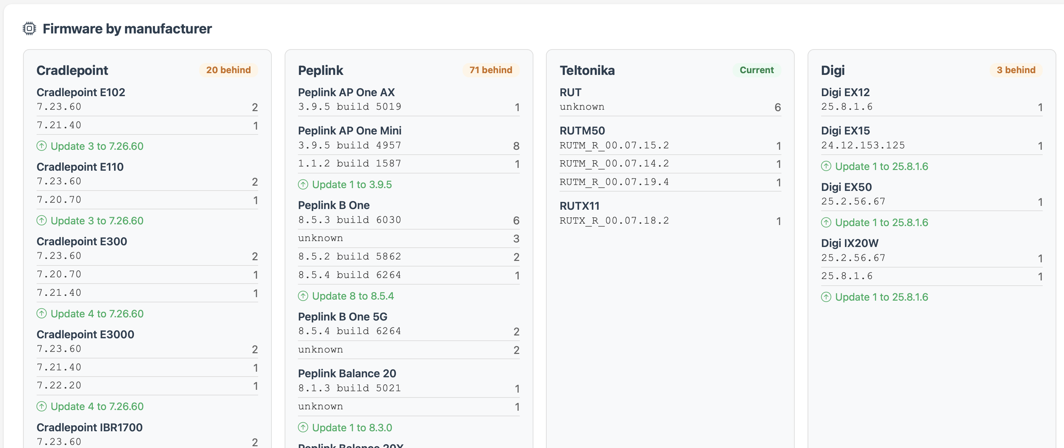
Figure: Firmware by manufacturer: exact version breakdown per model, with a behind-latest count per vendor.
Firmware currency. How current the fleet is versus the firmware catalog overall: how many devices are on the latest release, how many are behind, and how many have no catalog match. Devices offline 60+ days are excluded from the score since they can't be updated while dark. Also lists the specific models furthest behind.
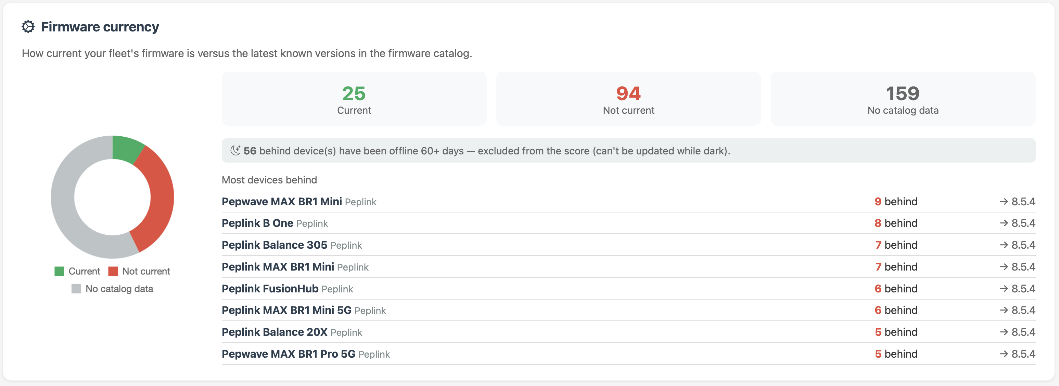
Figure: Firmware currency: current vs. not-current vs. no-catalog-data breakdown, plus the models furthest behind.
Pending firmware upgrades. Lists every device that is behind on firmware, sorted most-overdue first, with the exact version jump needed and links to release notes and an AI summary of what changed.
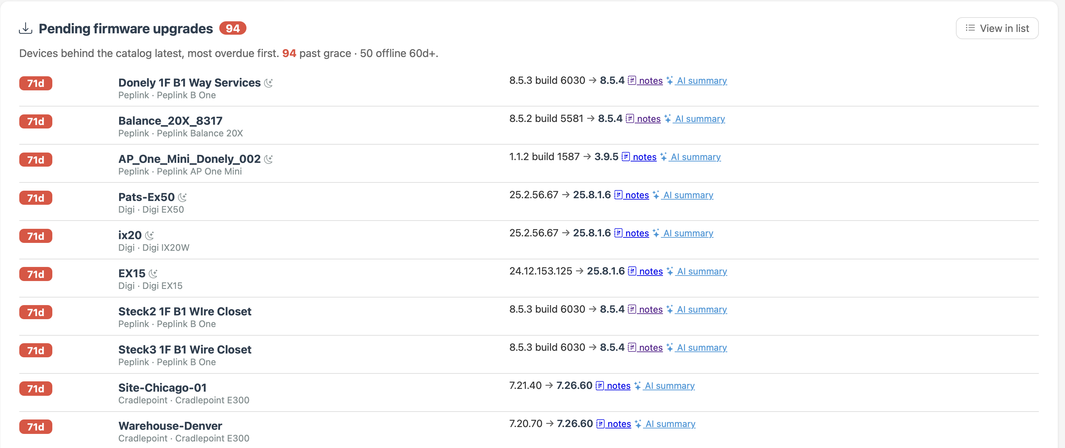
Figure: Pending firmware upgrades: devices behind on firmware, most overdue first, with version jumps and release notes.
Firmware adoption. Shows the percentage of the fleet running the latest firmware, broken out per vendor, along with the median number of days it takes your organization to patch after a release. A 30-day adoption curve shows whether that percentage is trending up or down.
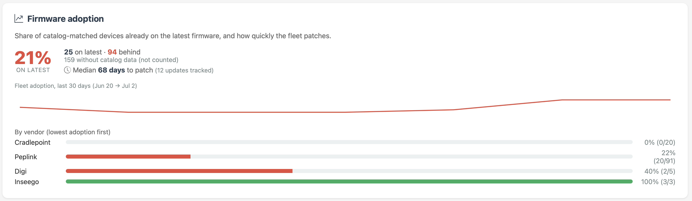
Figure: Firmware adoption: fleet-wide and per-vendor adoption percentage, median days-to-patch, and a 30-day trend curve.

3.8 Hardware temperature
The Hardware temperature card watches board and radio temperatures across the fleet and flags devices running hot. When everything is within range, the card shows a single green status line with the number of temperature-reporting devices and the hottest current reading (for example, "All 4 temperature-reporting devices nominal (hottest 42°C)"). Devices above the hot threshold are listed individually with their current reading so they can be investigated before heat becomes an outage.
Temperature support depends entirely on what each vendor's cloud reports. RouterStatus scans the metadata each platform returns for temperature readings and uses the hottest value found per device. Semtech/AirVantage devices report temperature reliably; some Peplink and CradlePoint models report board or radio temperature; other devices do not report temperature at all.
Note: Only devices whose vendor platform reports a temperature appear in this card. A device that is absent here is not necessarily running cool — its platform may simply not expose a temperature reading.

3.9 Fleet reports (PDF and email)
The same briefing that appears on screen can be exported as a report. From the Fleet briefing card, PDF downloads a formatted PDF immediately, and Email opens a modal where you enter a recipient address and click Send to deliver it as an email.
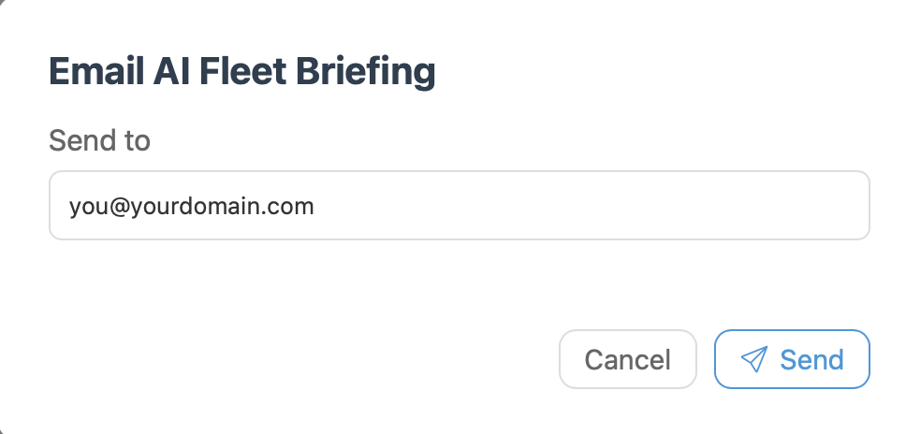
Figure: The Email AI Fleet Briefing modal: enter a recipient address and send the report.
Each report includes the health score and briefing, the recommended action list, a "what changed" summary since the last report, the highest-risk devices in the fleet, firmware adoption by manufacturer, pending firmware upgrades, frequently-flagged ("hot") hardware, a CVE breakdown by manufacturer, and a subscription-expiration forecast chart.
Note: Reports are generated on demand only; there is currently no scheduled or recurring report delivery. Use PDF or Email whenever you need a point-in-time report to share.

4. Security and CVE Monitoring
RouterStatus continuously matches your fleet against known router vulnerabilities (CVEs). The pink security banner on the dashboard summarizes how many devices have active CVEs, how many are Critical, and how many are End-of-Life (EOL).
Click View affected to filter the inventory down to just the at-risk devices. Each affected device card shows a severity badge (for example, 11 critical · 45 CVEs) and an End-of-life tag where applicable, so you can prioritize firmware updates and replacements.
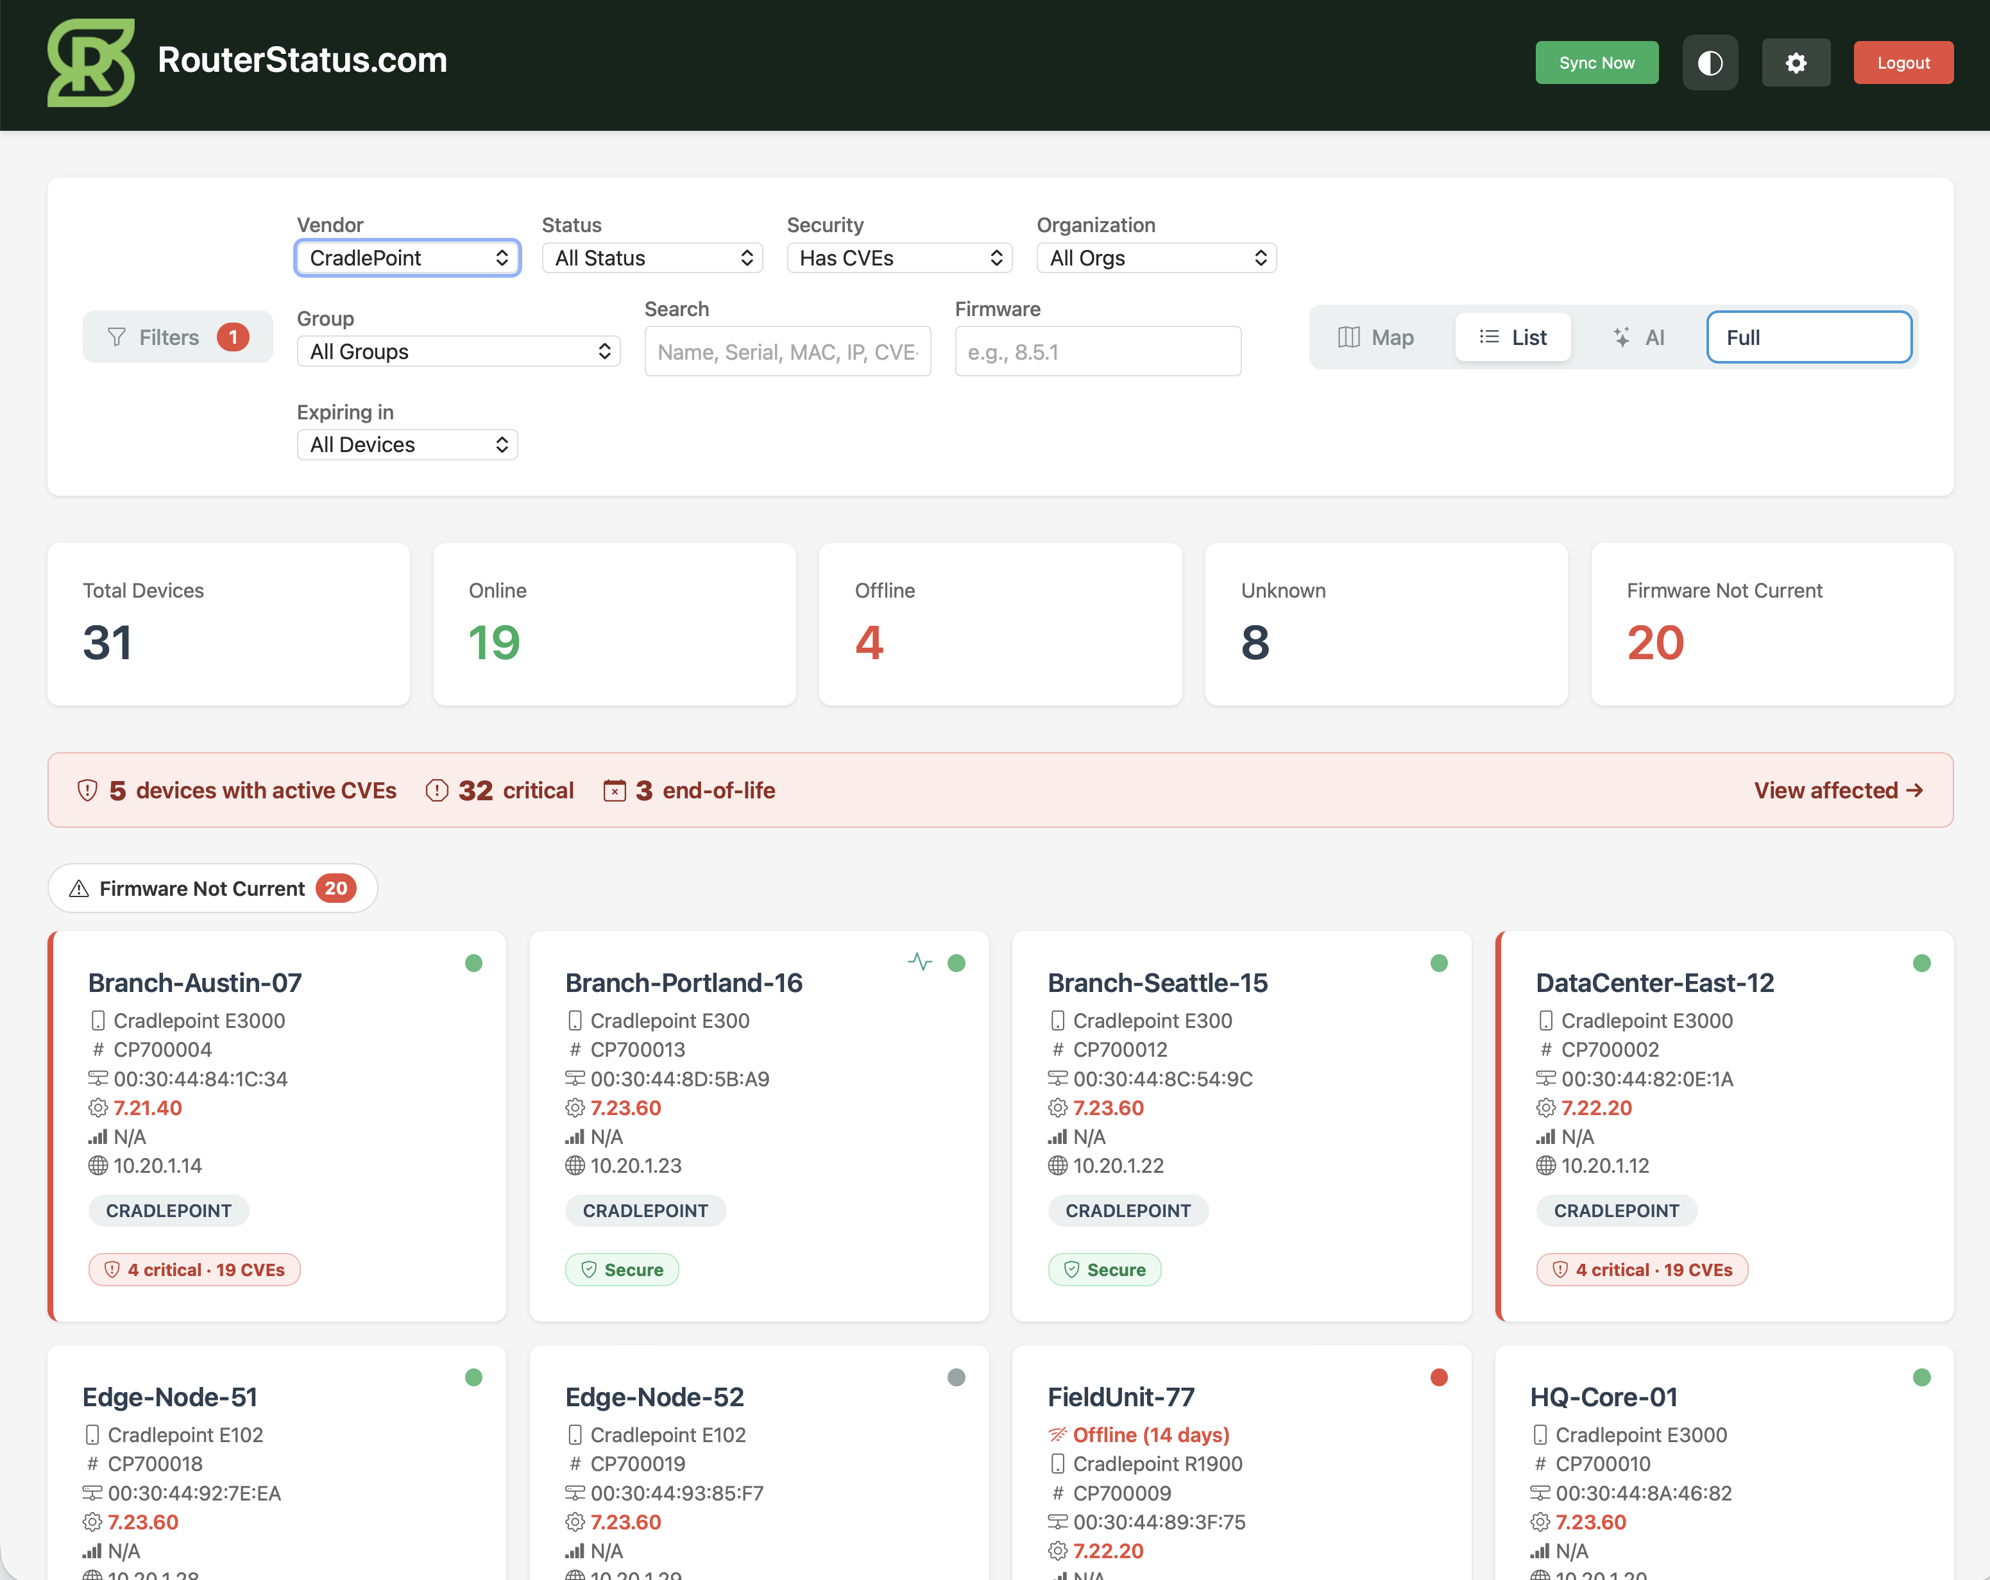
Figure: The View affected list: only devices with active CVEs, each showing its severity badge and EOL status.
Note: For a fleet-wide view of CVE exposure by manufacturer alongside firmware and subscription risk, see the AI Fleet Insights reports in Section 3.3.

5. Integrations: Connecting Your Router Platforms
Integrations are how RouterStatus pulls devices from each vendor's cloud platform. Open them from Settings, then the Integrations tab. The page lists every connected integration with its vendor, friendly name, and last sync time, plus edit and delete controls. The Integration Limits banner shows how many integrations of each vendor you have used out of your allowance, and Sync Groups re-pulls device groupings from the vendors.
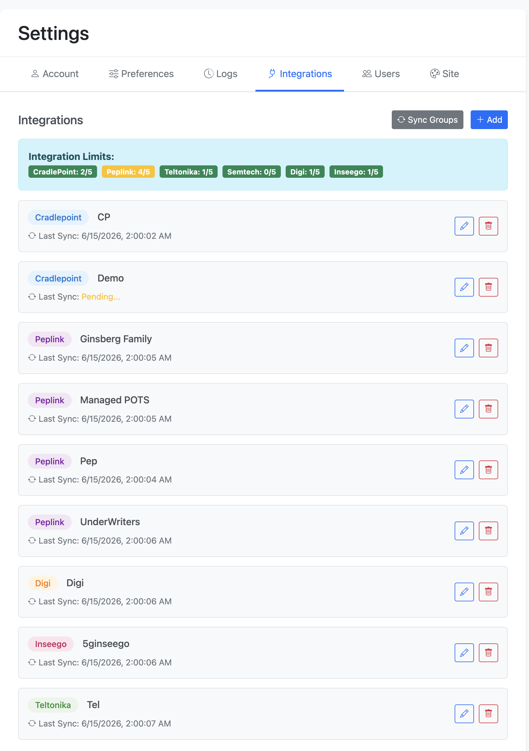
Figure: The Integrations tab: existing integrations, per-vendor limits, and the Add / Sync Groups controls.

5.1 Adding an integration
Click Add to open the Add Integration window. Give the integration a friendly Integration Name (for example, HQ, Warehouse, or a customer name), choose the Vendor, then fill in that vendor's credential fields and click Save. RouterStatus validates the credentials and begins its first sync.
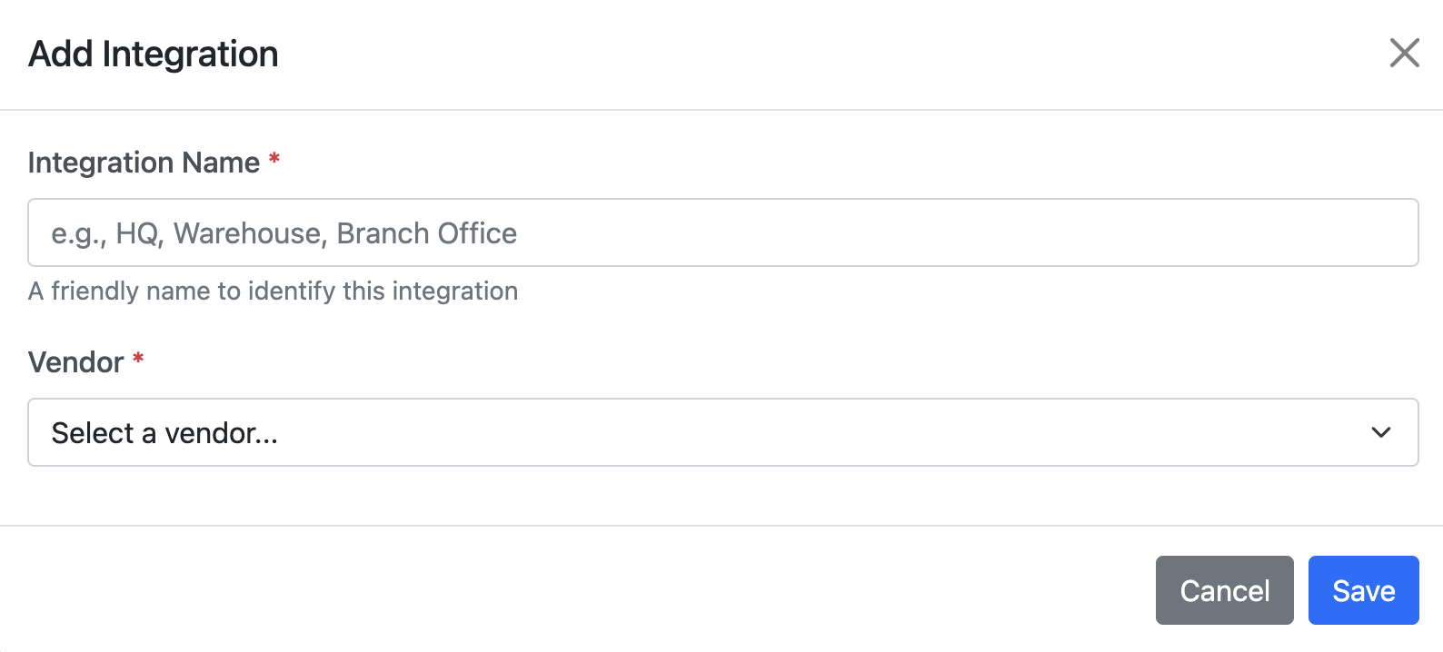
Figure: The Add Integration window. Choosing a vendor reveals that vendor's credential fields.
Note: For Cradlepoint, Digi, and Sierra Wireless, the secret half of the credential is shown only once, at creation. Copy and store it before closing the vendor's dialog.
Note: RouterStatus checks each new credential against your existing integrations for the same vendor. If it recognizes the same underlying vendor account, it blocks the save rather than creating a duplicate: "This [vendor] account is already connected as '[credential name]'. Adding it again would create duplicate, conflicting devices. Edit the existing integration instead, or remove it first if you really want to re-add it." If you see this message, edit the existing integration instead of adding a new one.
The sections below list each vendor's required fields and the exact steps to obtain them in the vendor's portal. Generating API credentials generally requires an administrator-level account on the vendor platform.

5.2 CradlePoint
Platform: Cradlepoint NetCloud Manager (NCM) — https://cradlepointecm.com/
Prerequisites: Adding API keys requires administrator privileges on the account. If you are a collaborator on someone else's account, your role must be Admin at the root of that account, not just on a subaccount.
Required fields in RouterStatus:
Field | What to enter
X-ECM-API-ID | User-level API Key ID (from the New APIv2 Key dialog).
X-ECM-API-KEY | User-level API Key Secret (shown once, in the same dialog).
X-CP-API-ID | Account-level API ID (from the NetCloud API Portal page).
X-CP-API-KEY | Account-level API Key (from the NetCloud API Portal page).

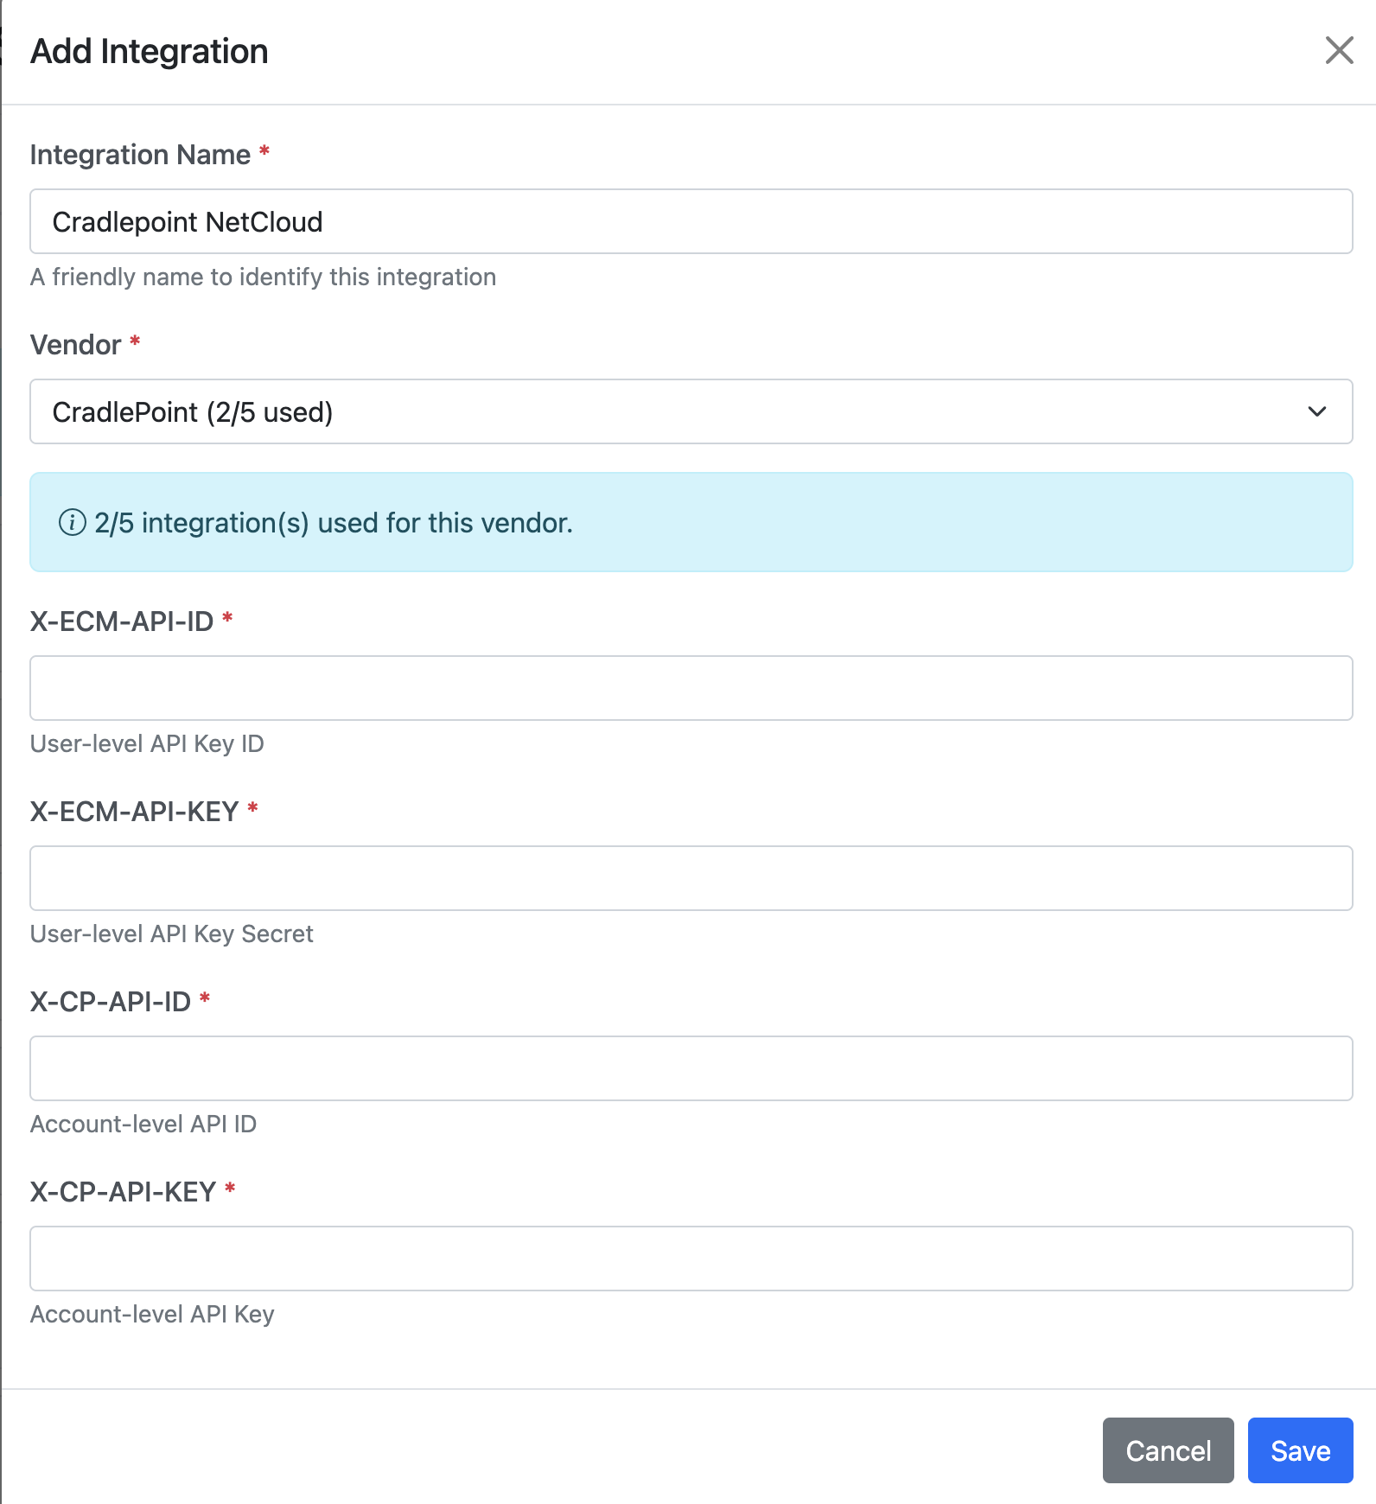
Figure: CradlePoint integration fields.

Where to get the credentials
- Log into NetCloud Manager at https://cradlepointecm.com/.
- Select Tools (left-side navigation), then open the NetCloud API tab.
- In the NCM API 2.0 section, click Add to open the Create API 2.0 Key page.
- Choose a Role from the drop-down and enter a Label. (Optionally click Change to tie the keys to a subaccount.)
- Click OK. The New APIv2 Key dialog shows your X-ECM-API-ID and X-ECM-API-KEY.
- Copy both values immediately and store them securely: NetCloud warns these cannot be retrieved once the dialog is closed. Click OK to close it.
- Still on the NetCloud API tab, click the API Portal link. This opens a separate NetCloud Manager API page that displays your account-level X-CP-API-ID and X-CP-API-KEY (distinct from the user-level X-ECM keys above).
- Enter all four values into the matching RouterStatus fields and click Save.
Note: Source: docs.cradlepoint.com — Generating API 2.0 Keys; Obtaining API Keys; Accessing the NetCloud API Portal. Ericsson (Cradlepoint's parent company) has a newer API v3 in beta as of mid-2026; v2, which RouterStatus uses, remains fully supported and Cradlepoint has stated it will stay available for at least a year after v3's release, so no action is needed now.

5.3 Peplink
Platform: Peplink InControl 2 — https://incontrol2.peplink.com/
Prerequisites: An InControl 2 account that is an admin of the target organization specifically. Being a global superuser is not enough on its own; Peplink support has confirmed the account must also be added as an admin on the organization you want RouterStatus to read.
Required fields in RouterStatus:
Field | What to enter
Client ID | From the InControl 2 Client Application you create.
Client Secret | Shown with the Client ID in the same Client Application popup.
Organization ID | The alphanumeric code from the InControl 2 organization's URL (the segment right after /o/), for the organization you want RouterStatus to read.

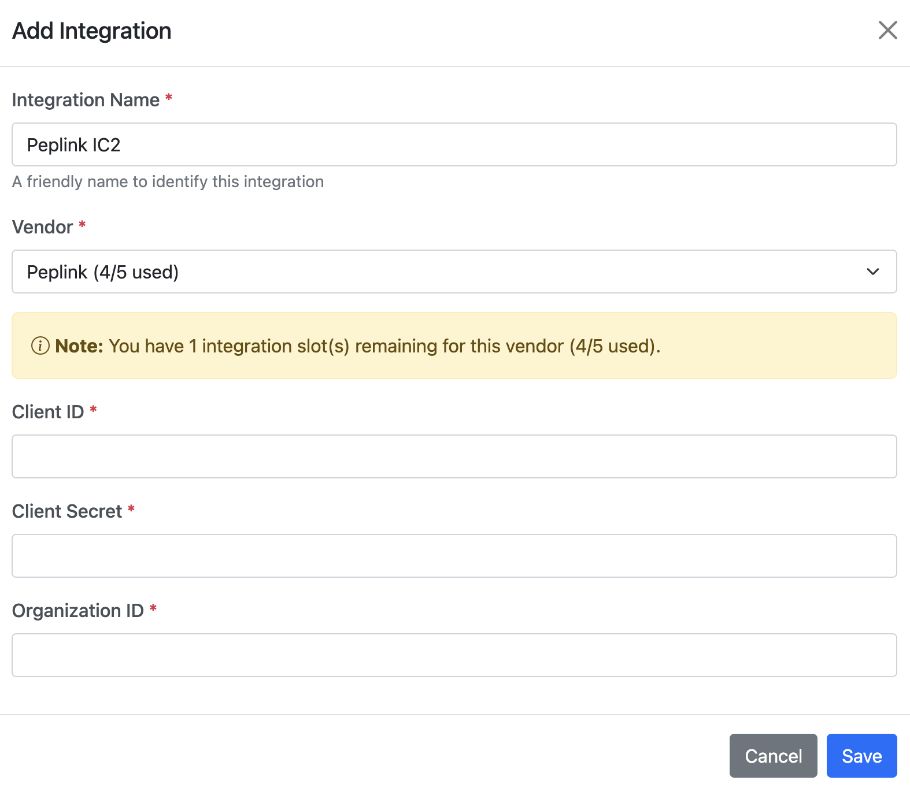
Figure: Peplink integration fields.

Where to get the credentials
- Sign in to InControl 2 at https://incontrol2.peplink.com/.
- Click your username or email (upper-right) to open the Account Information page.
- Scroll to the Client Application section and click New Client.
- Enter an application Name, check Enable, and click Save.
- Click the new application's name; a popup displays the Client ID and Client Secret. Copy both.
- Open the target organization in InControl 2 and look at the browser's address bar. The URL follows the pattern https://[instance].ic.peplink.com/o/[ORGANIZATION ID]/n/.../d/.../overview, for example https://mars.ic.peplink.com/o/Xk4pQz/n/7/d/220/overview. The segment right after /o/ (Xk4pQz in that example) is the Organization ID: an alphanumeric code, not a plain number.
- Enter the Client ID, Client Secret, and Organization ID into RouterStatus and click Save.
Note: If you'd rather confirm the Organization ID through the API instead of the URL, request an access token (POST to https://api.ic.peplink.com/api/oauth2/token with your Client ID, Client Secret, and grant_type=client_credentials), then call GET https://api.ic.peplink.com/rest/o with that token; the response lists every organization you administer along with its id. Sources: peplink.com/ic2-api-doc; forum.peplink.com (Peplink staff guidance on organization admin requirements).

5.4 Teltonika
Platform: Teltonika RMS (Remote Management System) — https://rms.teltonika-networks.com/
Prerequisites: Two-Factor Authentication (2FA) must be enabled on your RMS account before a token can be created.
Required fields in RouterStatus:
Field | What to enter
API Key | A Personal Access Token generated in Teltonika RMS.

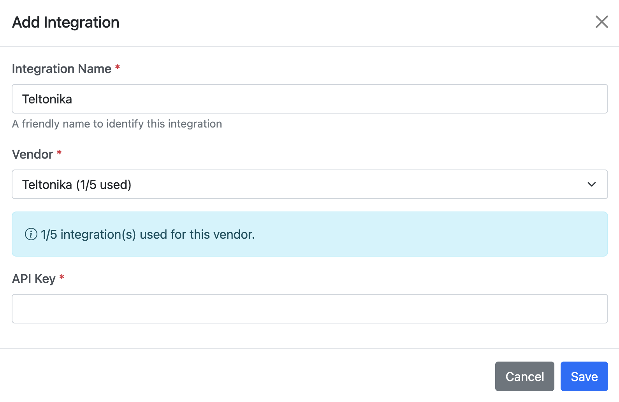
Figure: Teltonika integration field.

Where to get the credentials
- Log into RMS at https://rms.teltonika-networks.com/.
- Click your account name (top-right corner), then select Account Settings.
- Open the Security tab (left sidebar) and enable Two-Factor Authentication, any method works: a single-use email code, the Teltonika ID app, or a TOTP authenticator app such as Google Authenticator or Authy. This is required before a token can be created.
- In Account Settings, go to API, then Access tokens.
- Click Add new access token.
- Enter a name for the token and select the Scopes it needs (Scopes control what the token is allowed to access; RMS lists the available options at creation time).
- Save the token; it appears in the access-token table.
- Copy the token immediately, paste it into the RouterStatus API Key field, and click Save.
Note: RMS does not publicly document its full list of scope names or whether tokens expire and need periodic renewal. Check the options shown on your own Access tokens screen at creation time, and if RouterStatus's sync stops working months later, a token renewal is a reasonable first thing to check. Sources: developers.rms.teltonika-networks.com; wiki.teltonika-networks.com/view/RMS_API; Teltonika Networks newsroom (2FA in RMS).

5.5 Semtech / Sierra Wireless
Platform: Sierra Wireless, a Semtech company (Semtech completed its acquisition of Sierra Wireless in January 2023), AirVantage / AirLink Management Service (ALMS) — na.airvantage.net (North America) or eu.airvantage.net (Europe). The product name AirVantage and both platform URLs are unchanged by the acquisition.
Prerequisites: An AirVantage/ALMS account with access to the Develop activity, and a Profile you can assign to the API client with at least View rights on Systems, Gateways, and Subscriptions. Use the server (NA or EU) that hosts your account.
Required fields in RouterStatus:
Field | What to enter
Client ID | Generated for the API Client you create in AirVantage.
Secret Key | Generated alongside the Client ID for the same API Client.

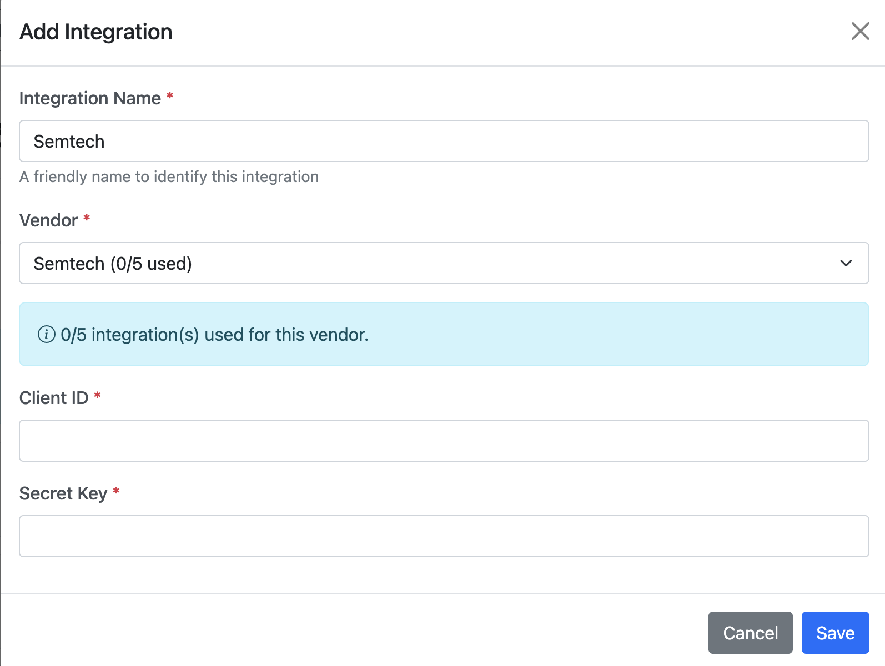
Figure: Semtech / Sierra Wireless integration fields.

Where to get the credentials
- Log into your AirVantage platform (na.airvantage.net or eu.airvantage.net).
- Go to Develop, then API Clients.
- Click Create to open the Create API Client window.
- Provide a Name for the client.
- Explicitly set the flow type to Client Credentials. New API clients do not default to this, and RouterStatus (a server-to-server integration, not a user login) needs it set this way to work.
- Under Profiles, assign a profile that grants at least View rights on Systems, Gateways, and Subscriptions, this is enough for RouterStatus to read your device inventory; no write or delete rights are needed.
- Save. AirVantage generates a Client ID and a Secret Key on the client's detail page. Copy both immediately.
- Enter them into RouterStatus and click Save.
Note: AirVantage's documentation doesn't state whether the Secret Key can be viewed again later, so treat it like a one-time reveal and copy it right away to be safe. Source: source.sierrawireless.com — AirVantage Getting Started with the API; AirVantage Profile Management reference.

5.6 Digi
Platform: Digi Remote Manager (DRM) — https://remotemanager.digi.com/
Prerequisites: A Digi Remote Manager account with permission to create API keys. Note for subaccounts: if your DRM account is a subaccount under a reseller or parent organization, the parent account must first enable the "Allow API Keys" toggle for your subaccount (Account Settings, Accounts, select the subaccount, Details tab) before you can create your own keys.
Required fields in RouterStatus:
Field | What to enter
API Key ID | Shown in the New API key window in Digi Remote Manager.
API Key Secret | Shown once, with the ID, in the same window.

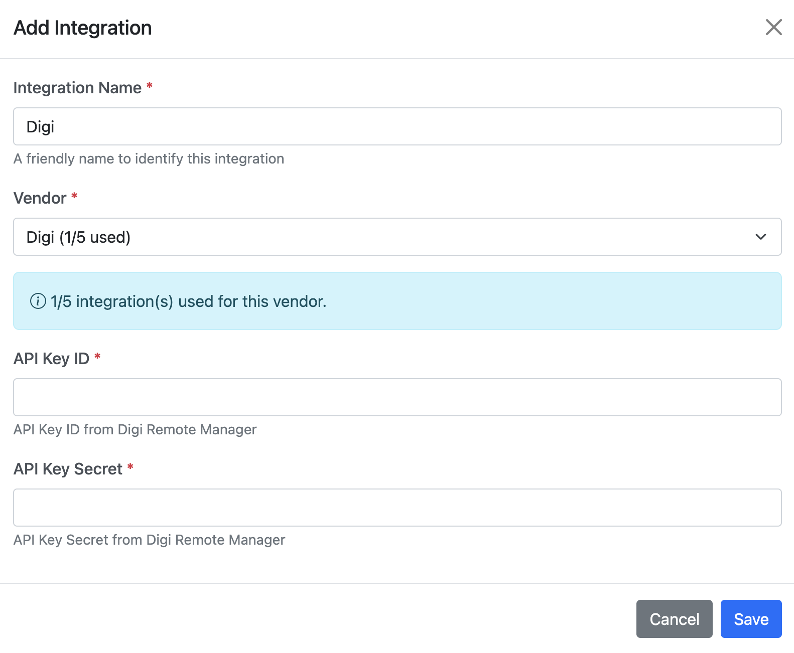
Figure: Digi integration fields.

Where to get the credentials
- Log into Digi Remote Manager at https://remotemanager.digi.com/.
- In the header menu, click Account Settings, then API keys.
- Click Create.
- Type a description for the key (for example, "RouterStatus integration") and click Confirm.
- The New API key window displays the API Key ID and API Key Secret.
- Copy both immediately and store them securely: the secret is shown only once and cannot be retrieved again. Click Close.
- Enter both values into RouterStatus and click Save.
Note: A Digi API key inherits the full permissions of the user who created it, there's no separate scoping UI to restrict what a key can do. Digi's own guidance is to create a lower-privileged user account first and generate the key under that user, rather than trying to restrict the key itself. Digi also emails the account when a new key is created, worth a look if you ever want to audit who's generated keys. Sources: docsportal.digi.com — Create an API key; Enable an account to create API keys; Security considerations.

5.7 Inseego
Platform: Inseego Connect — connect.inseego.com, with a linked developer portal at connect-api.inseego.com.
Prerequisites: An Inseego Connect account on the Advanced tier (needed for External API access). If you don't have this yet, contact Inseego (inseego.com/support or your Inseego reseller) to get it added, this is a support/sales conversation, not a self-service toggle.
Required fields in RouterStatus:
Field | What to enter
Subscription Key | The API subscription key shown on the invited user's Profile tab at connect-api.inseego.com.
Tenant Name | The exact same value as the Subscription Key Name shown in Inseego Connect's APIs page, this is your tenant name.
Application Name | Defaults to "Inseego Connect"; leave as-is unless Inseego tells you otherwise.

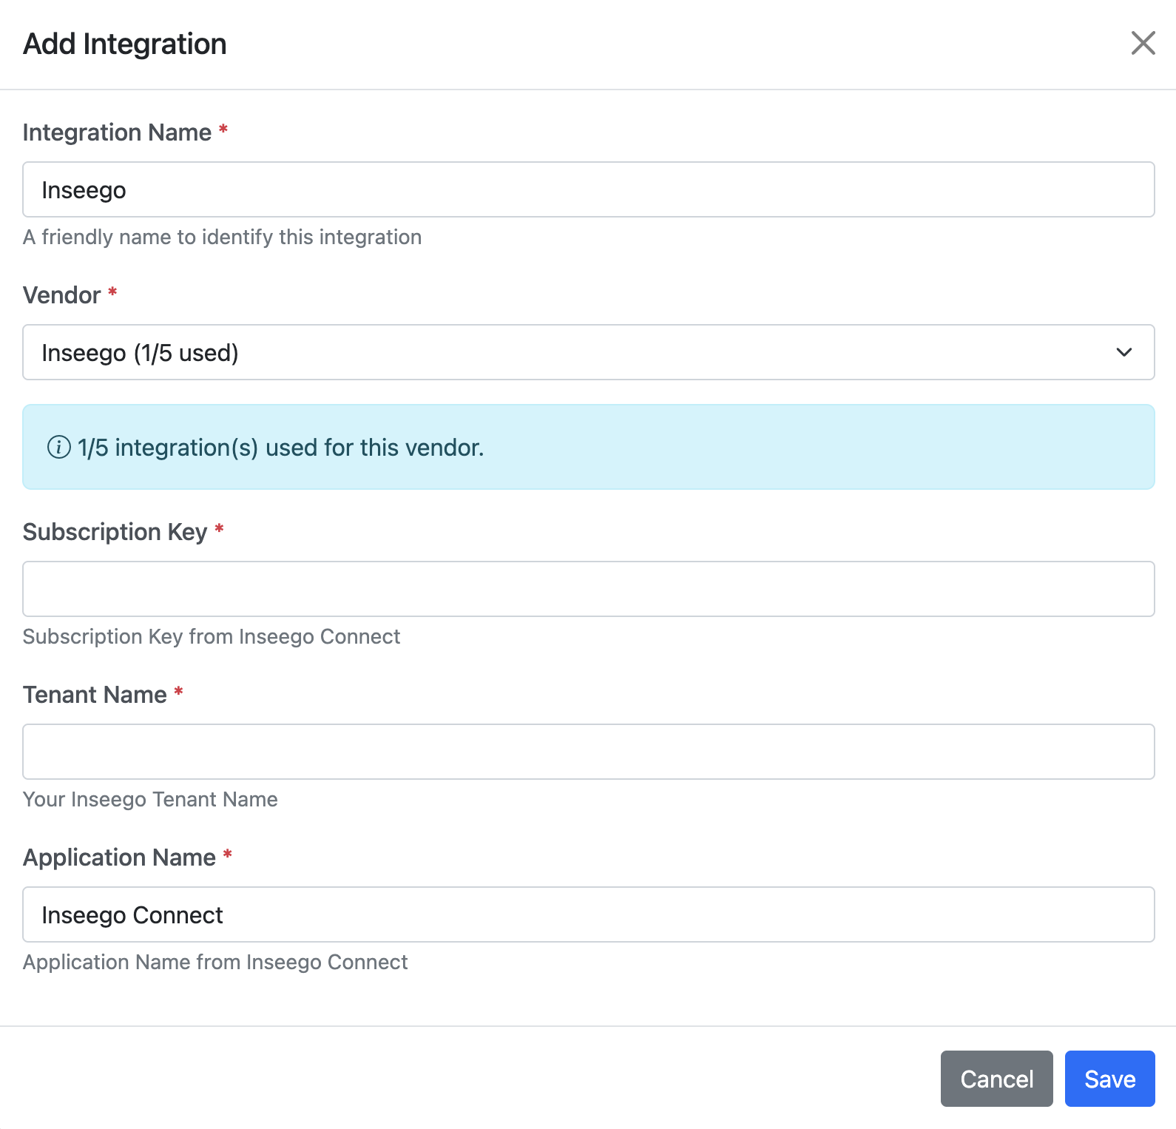
Figure: Inseego integration fields.

Where to get the credentials
- Log into Inseego Connect (connect.inseego.com) as a user with admin/API-management permissions.
- Go to Settings, then the APIs page.
- Click Create API Key, select the user the key is for from the dropdown, and click Create. Inseego emails that user setup instructions.
- The invited user follows the link in that email to connect-api.inseego.com, verifies their email and code, and finishes setting up developer portal access.
- On the developer portal, open the Profile tab, the Subscription Key (Primary or Secondary) is shown there. Copy it into RouterStatus's Subscription Key field.
- Back in Inseego Connect's APIs page, find that user's row: the Subscription Key Name column is your Tenant Name, copy that exact string into RouterStatus's Tenant Name field.
- Leave Application Name as "Inseego Connect" and click Save.
Note: Inseego's documentation confirms Subscription Key Name is the tenant name, that part is verified, not a guess. Application Name isn't otherwise documented publicly, so "Inseego Connect" is the only known value; if RouterStatus can't validate your credentials, that's worth double-checking with Inseego support. Sources: inseego.com Connect user guide — APIs Page Overview, Creating API Keys, Signing Up.

6. Settings
Open Settings from the gear icon in the dashboard header. Settings has six tabs: Account, Preferences, Logs, Integrations (covered in Section 5), Users, and Site. Super Admins also see the Admin Panel button (Section 7).

6.1 Account
Update your profile (first name, last name, email, company) and change your password. Leave the password fields blank to keep your current password.
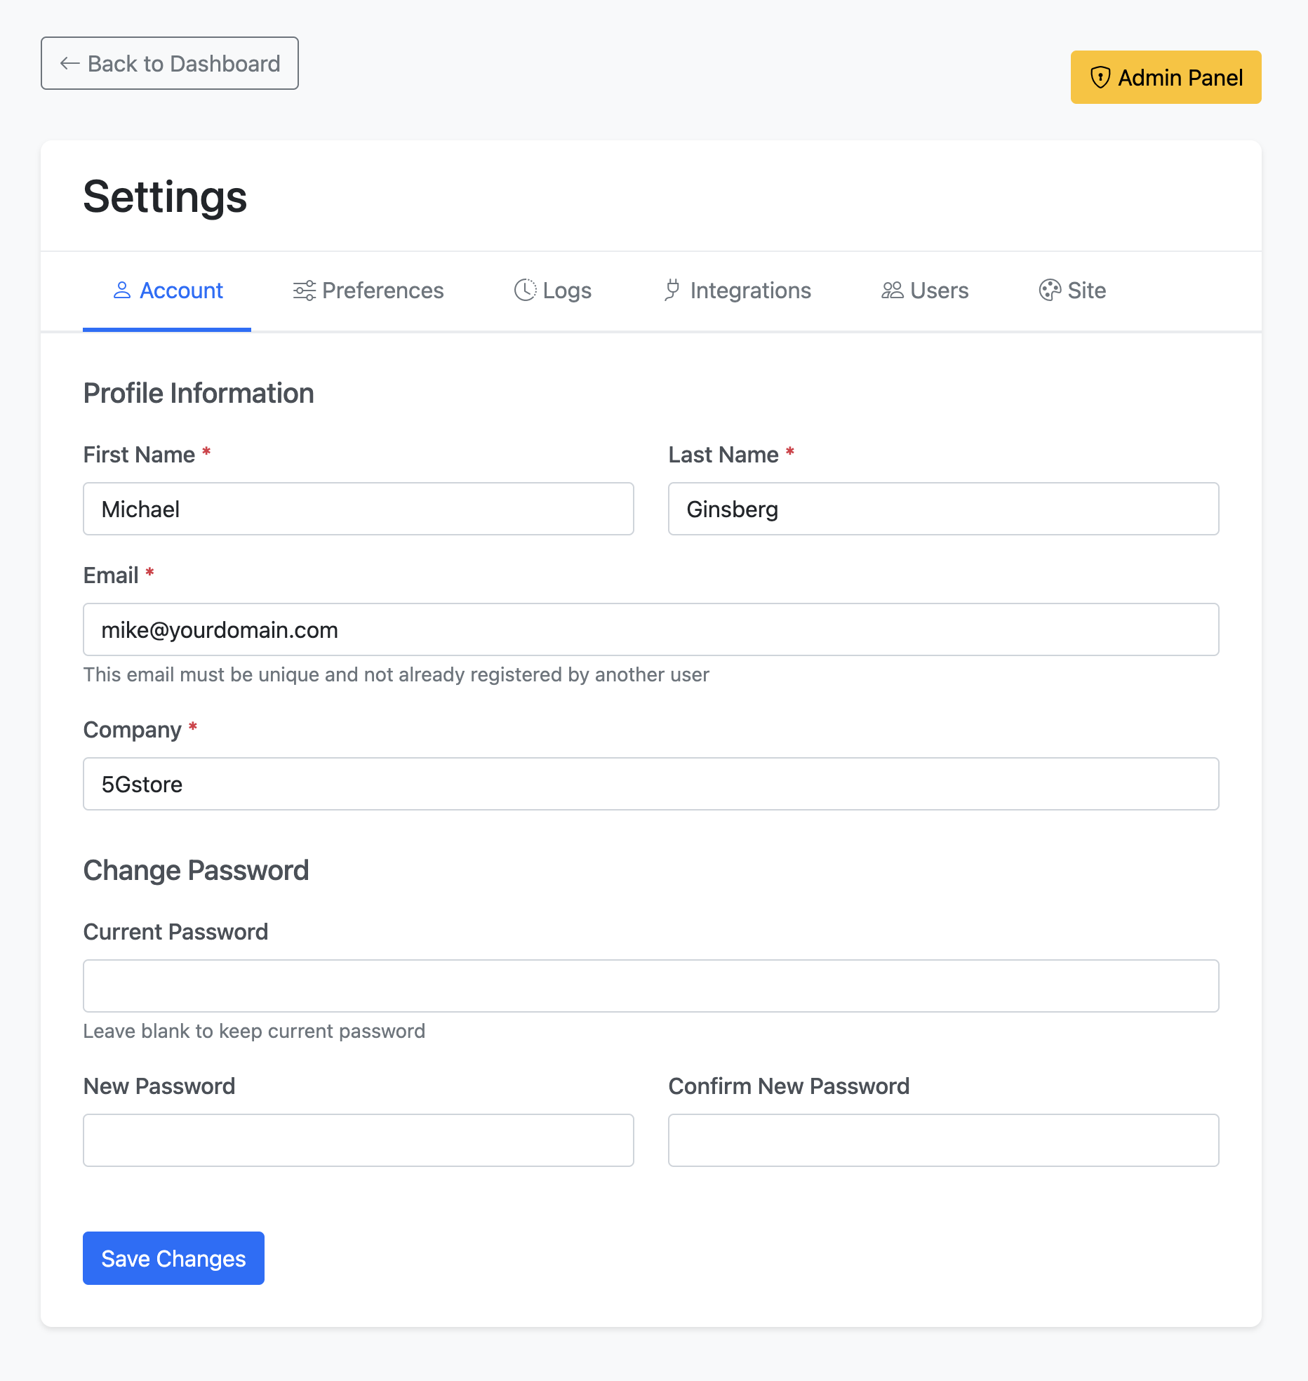
Figure: The Account tab: profile information and password change.

6.2 Preferences
Control how the dashboard behaves and looks. Sync Preferences sets whether the fleet auto-syncs each time you open the dashboard. Display Preferences sets the default view (List or Map). Default List View lets you build and save custom column layouts (for example, an Expiration view or a Firmware view) and choose which one loads by default. Dashboard Filters lets you show or hide each filter control.
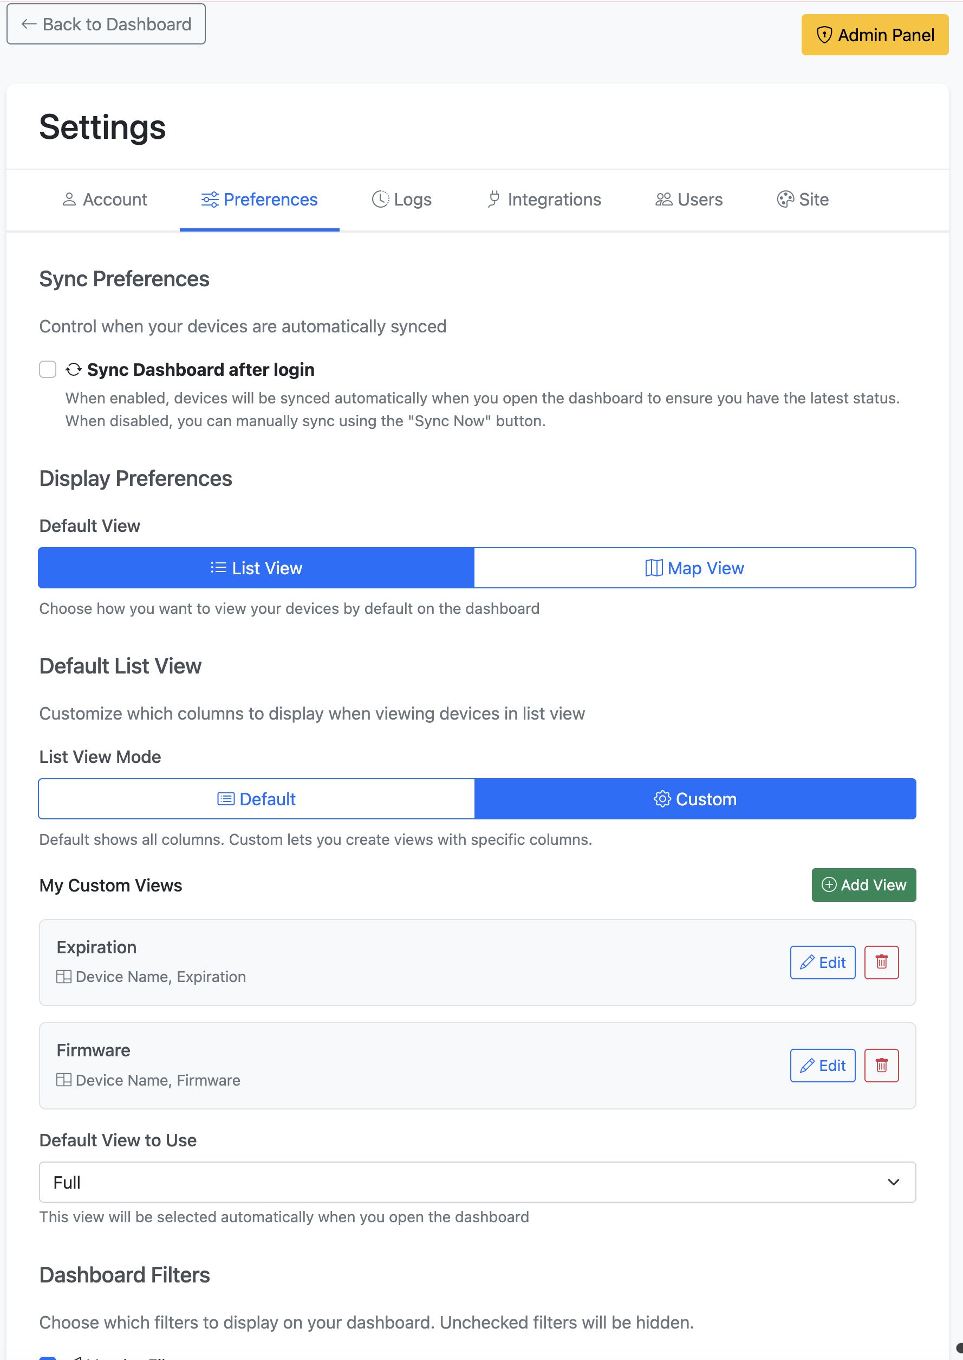
Figure: Preferences: sync behavior, default view, and saved custom list views.
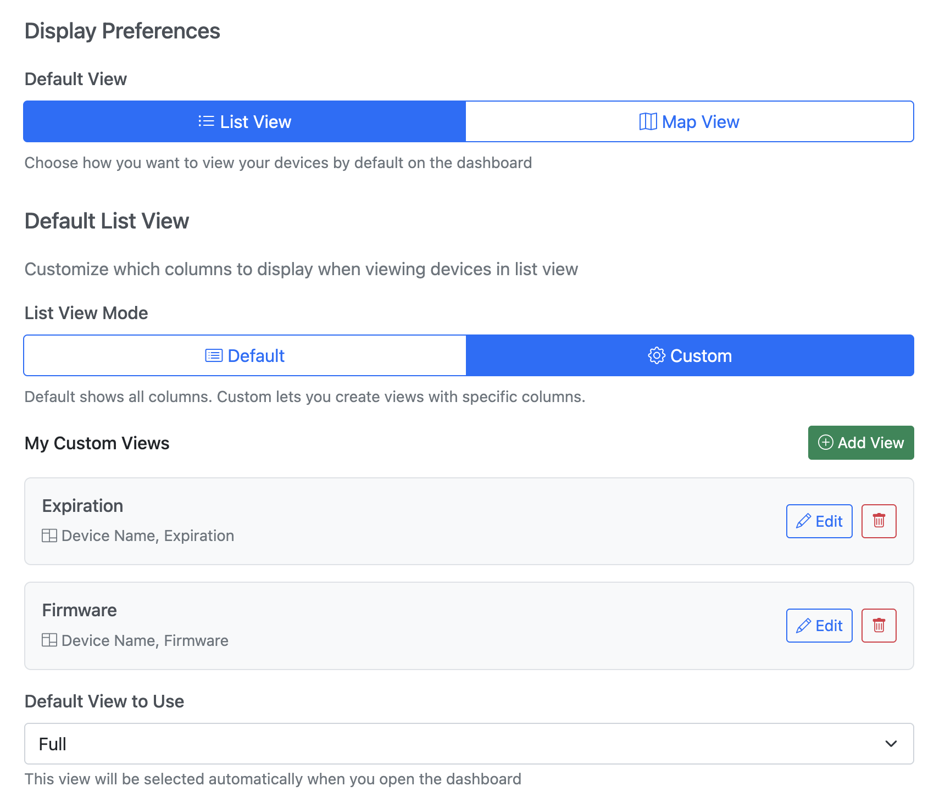
Figure: Preferences (continued): the default view selector and Dashboard Filter toggles.
Note: How often devices sync automatically in the background (as opposed to the on-open sync above) is a platform-wide setting controlled by a Super Admin in the Admin Panel — see Section 7.1.

6.3 Activity Logs
The Logs tab is an audit trail of activity in your organization: device status changes, logins, integration changes, and more. Filter by user, action, or date range, and click Refresh for the latest entries.
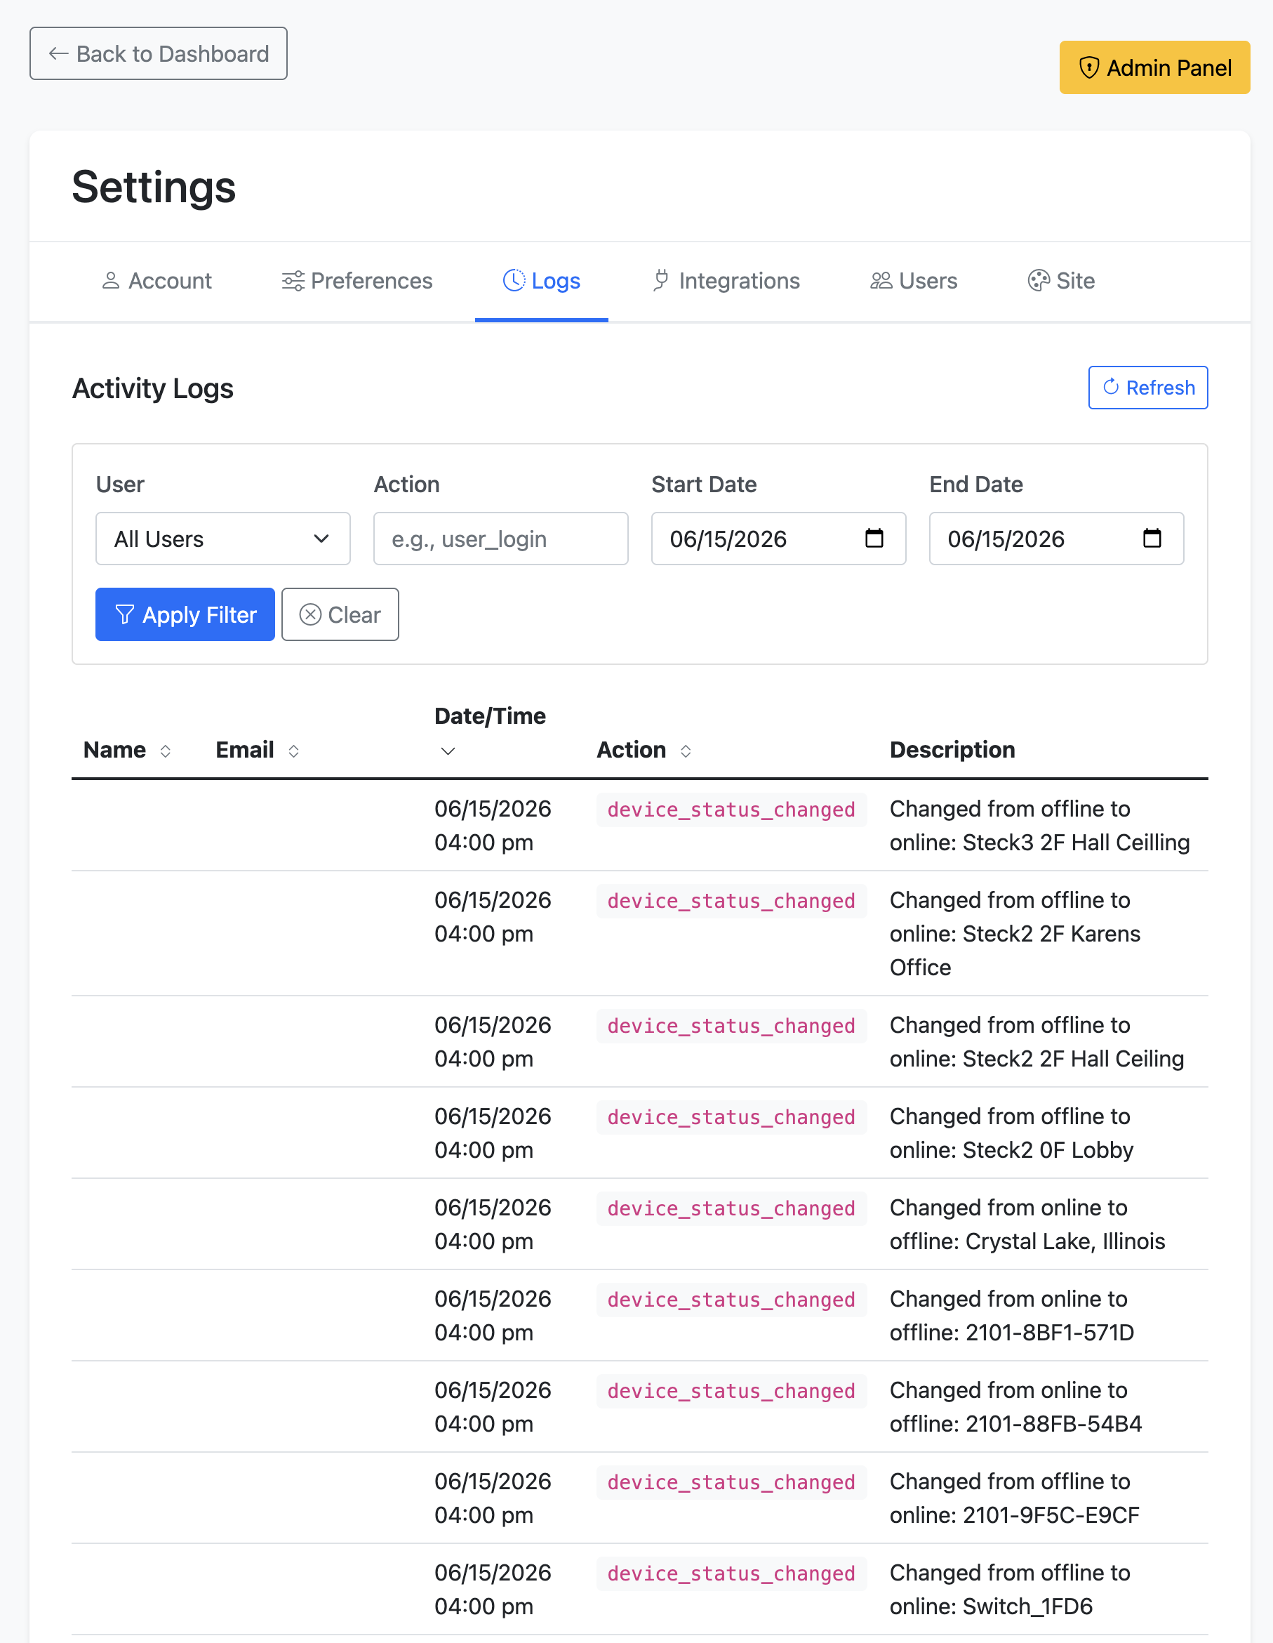
Figure: The Logs tab: a filterable audit trail of organization activity.

6.4 Users and invitations
Manage who can access your organization. The Users tab lists each user with their role, status, and last login, and lets you edit, deactivate, or impersonate (sign in as) a user. Filter by role or search by name, email, or company.
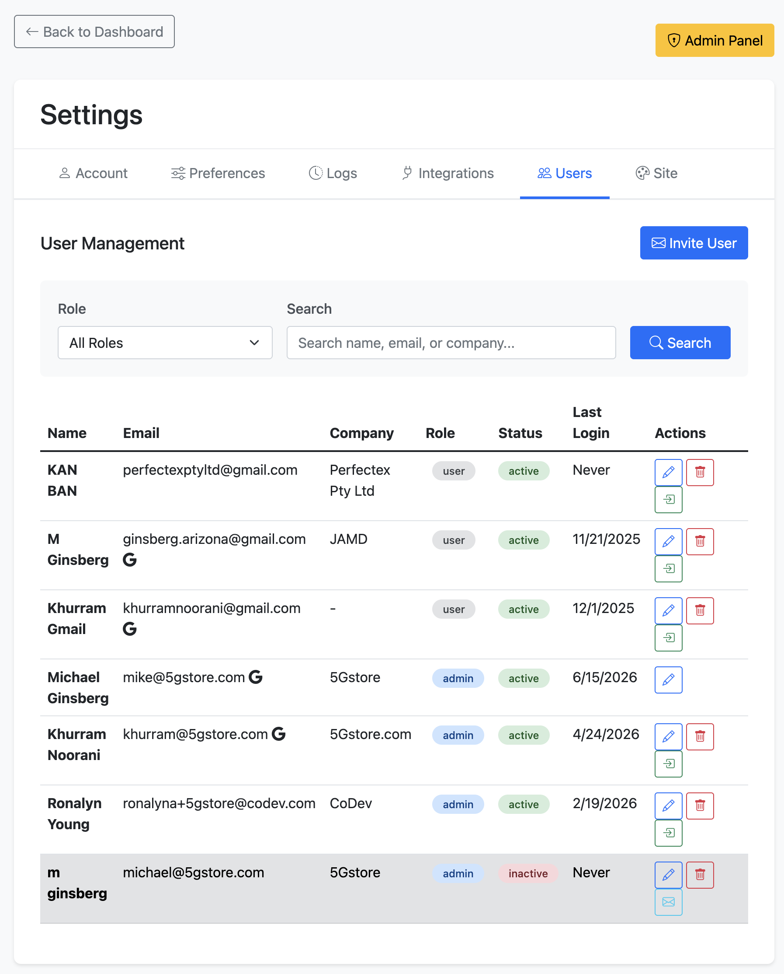
Figure: The Users tab: organization user management.
Click Invite User to add someone. Enter their name, email, and company, choose a Role (User or Admin), and set Group Access: All Groups, or Select Groups to restrict them to specific device groups. RouterStatus emails them an invitation.
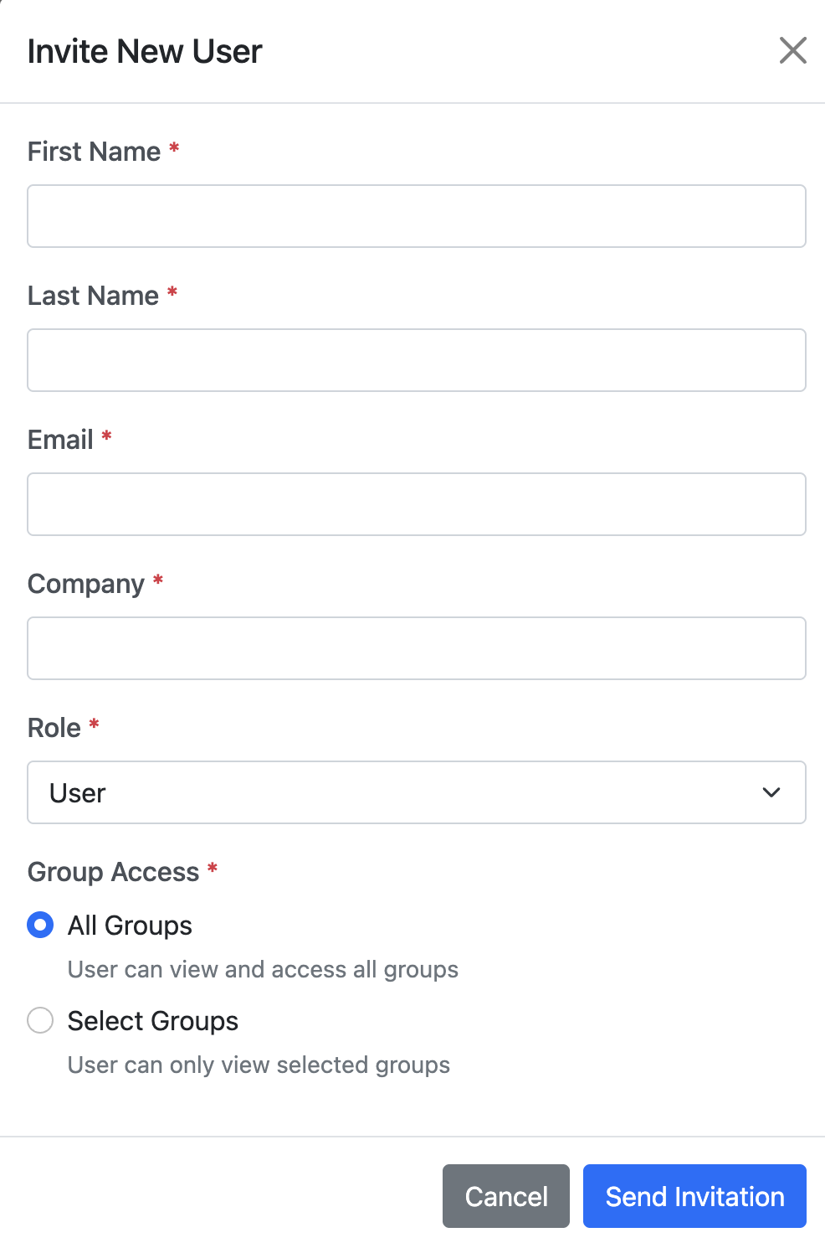
Figure: The Invite New User dialog, including role and group-access controls.

6.5 Site (White-Label Branding)
The Site tab white-labels the dashboard. Upload your own Site Logo and Favicon, set the Headline text, and choose the header text and background colors. A live Preview shows the result. Under Device Information, the Show Device Meta Data control decides who can see the raw device metadata (JSON) in the device detail window.
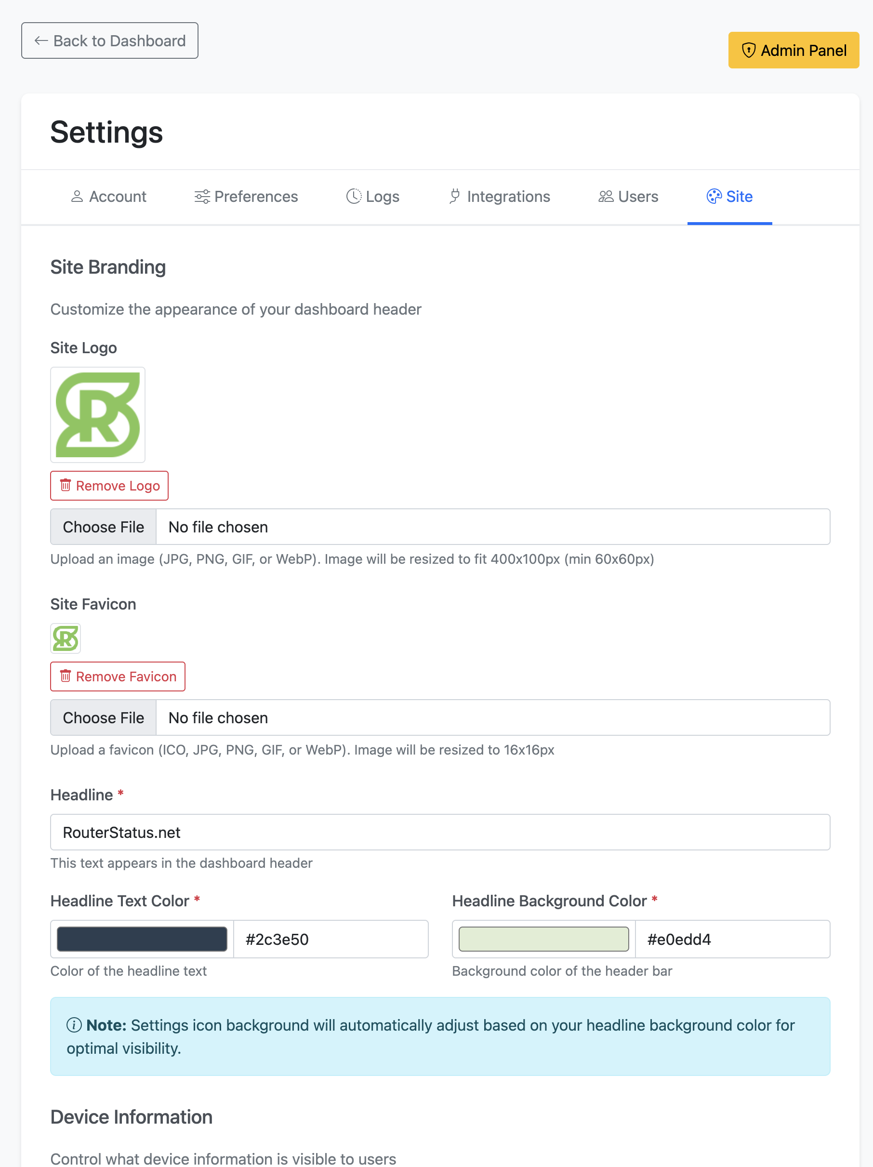
Figure: The Site tab: logo, favicon, headline, and header colors.
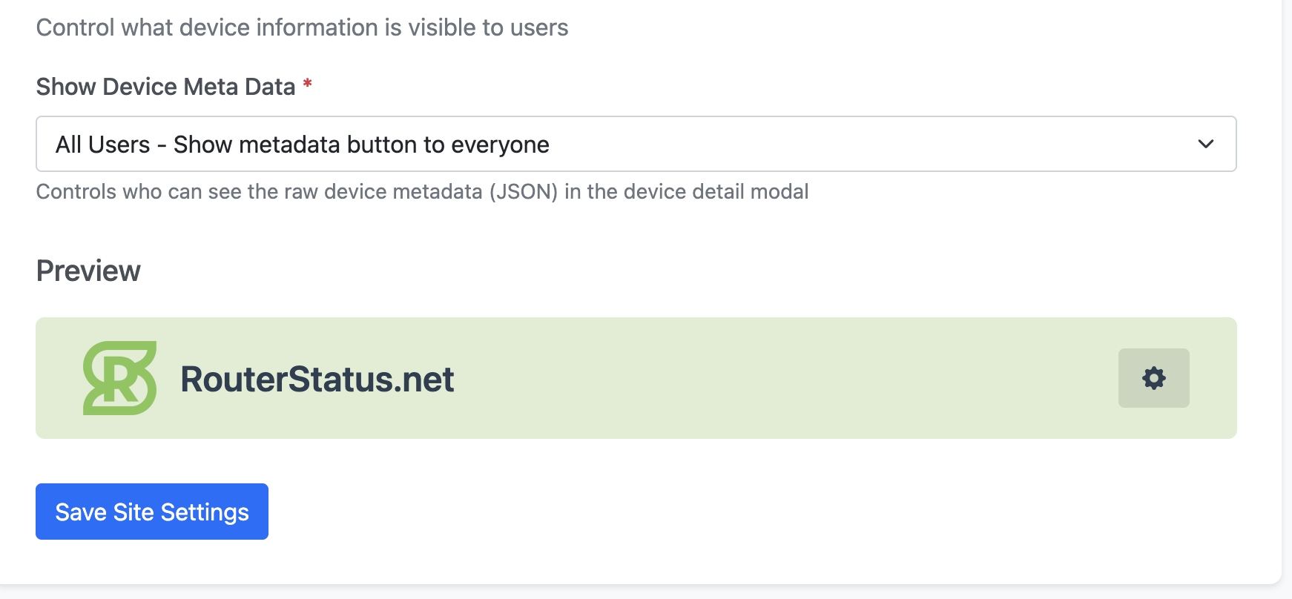
Figure: Site (continued): metadata visibility control and the live header preview.

7. Admin Panel (Super Admin)
The Admin Panel is the platform-wide control center, available only to Super Admins via the Admin Panel button in Settings. It has four tabs: Config, Tenants, Users, and Logs.

7.1 Config
Global System Configurations that apply across the whole platform. Minimum Devices for Navigation sets the device count above which pagination appears; Maximum Devices per Page sets how many devices show per page once pagination is active.
Background Sync Interval. Sets how often RouterStatus automatically pulls fresh data from every connected vendor platform in the background, independent of any individual user opening the dashboard. Choose 15 minutes, 30 minutes, 1 hour, 2 hours, 4 hours, or 6 hours. This is a single, platform-wide setting: it applies to every tenant's scheduled background sync.
Note: The Background Sync Interval only affects the automatic background sync. Clicking Sync Now on the dashboard or Integrations tab always syncs immediately, regardless of this setting.

7.2 Tenants
Tenant Management lists every organization (tenant) on the platform with its member count and creation date, and lets you search and edit tenants.
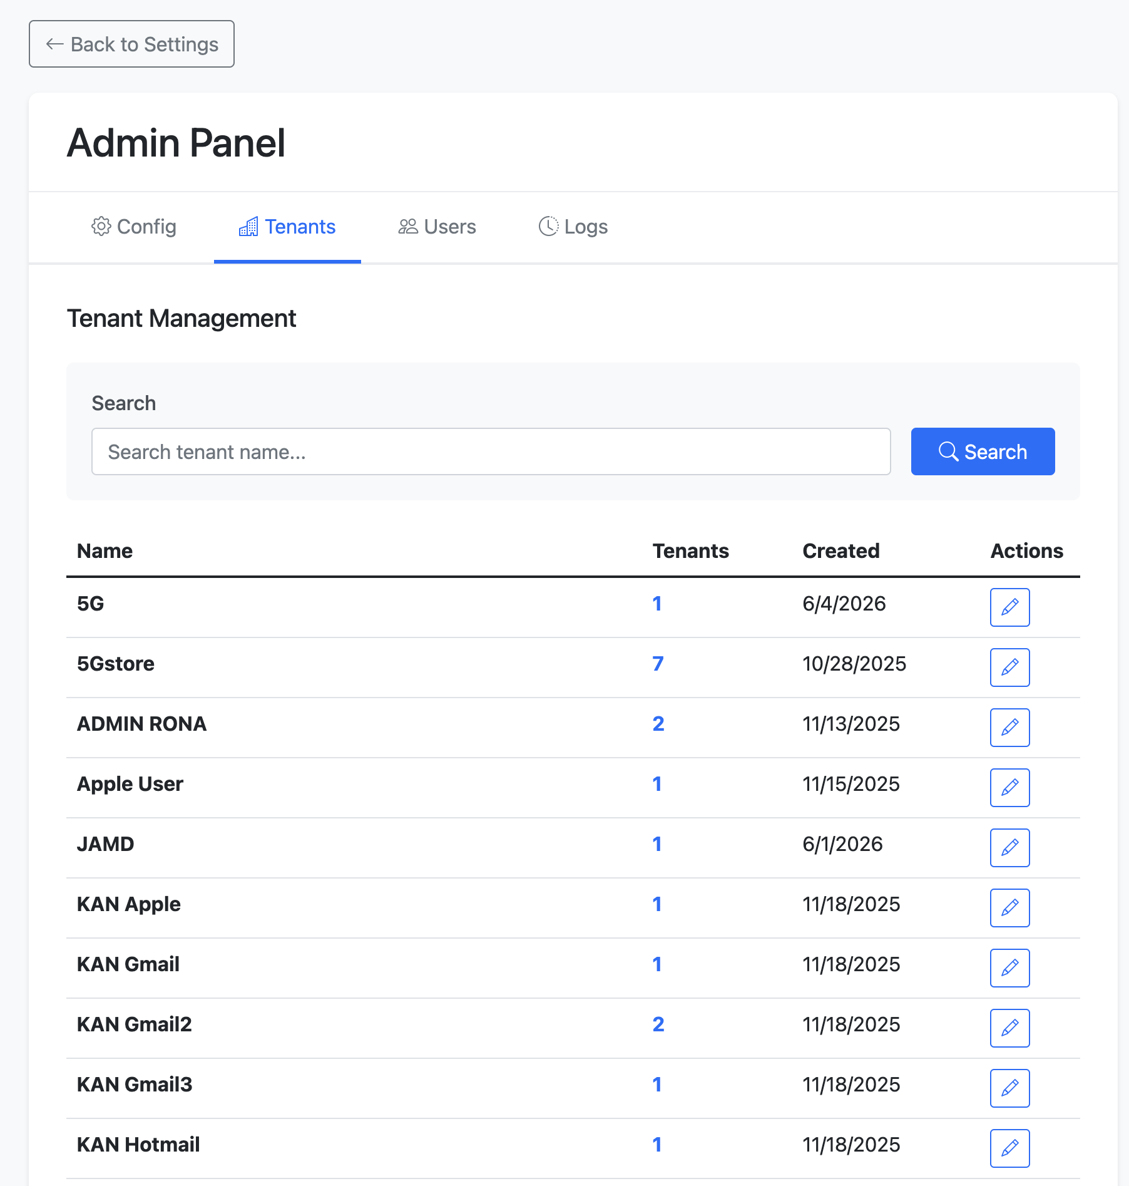
Figure: Admin Panel: tenant management.

7.3 Users
A cross-tenant view of every user on the platform. Filter by tenant and role, and search across all accounts. Roles include Super Admin, Admin, and User.
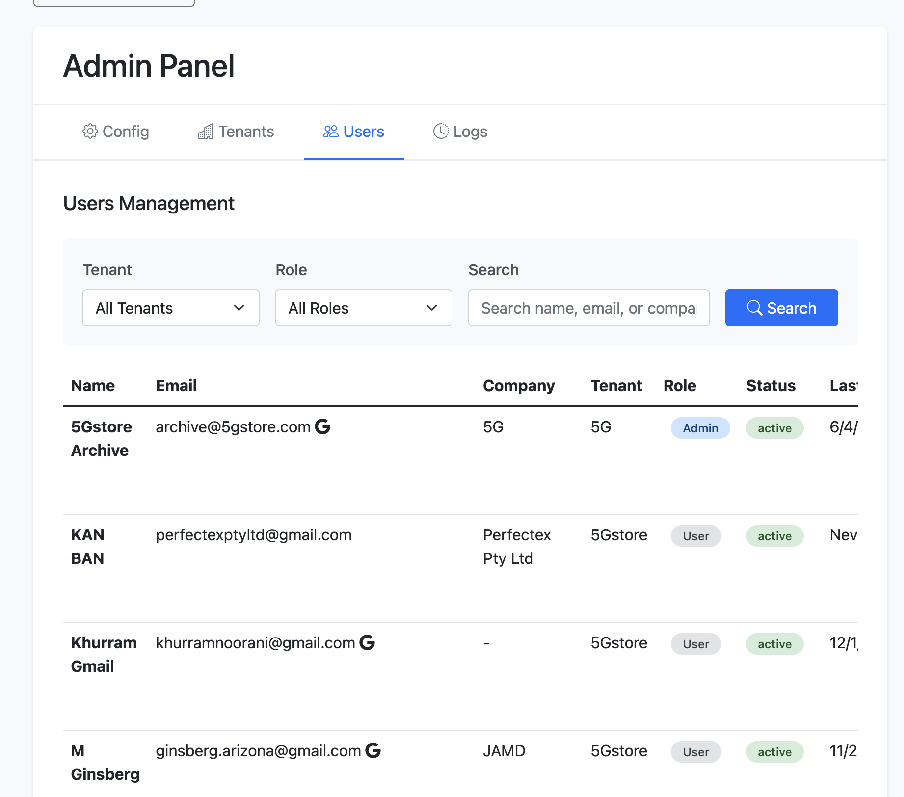
Figure: Admin Panel: cross-tenant user management.

7.4 Logs
The platform-wide activity log across all tenants. Filter by tenant, user, action, and date range for a complete audit trail.
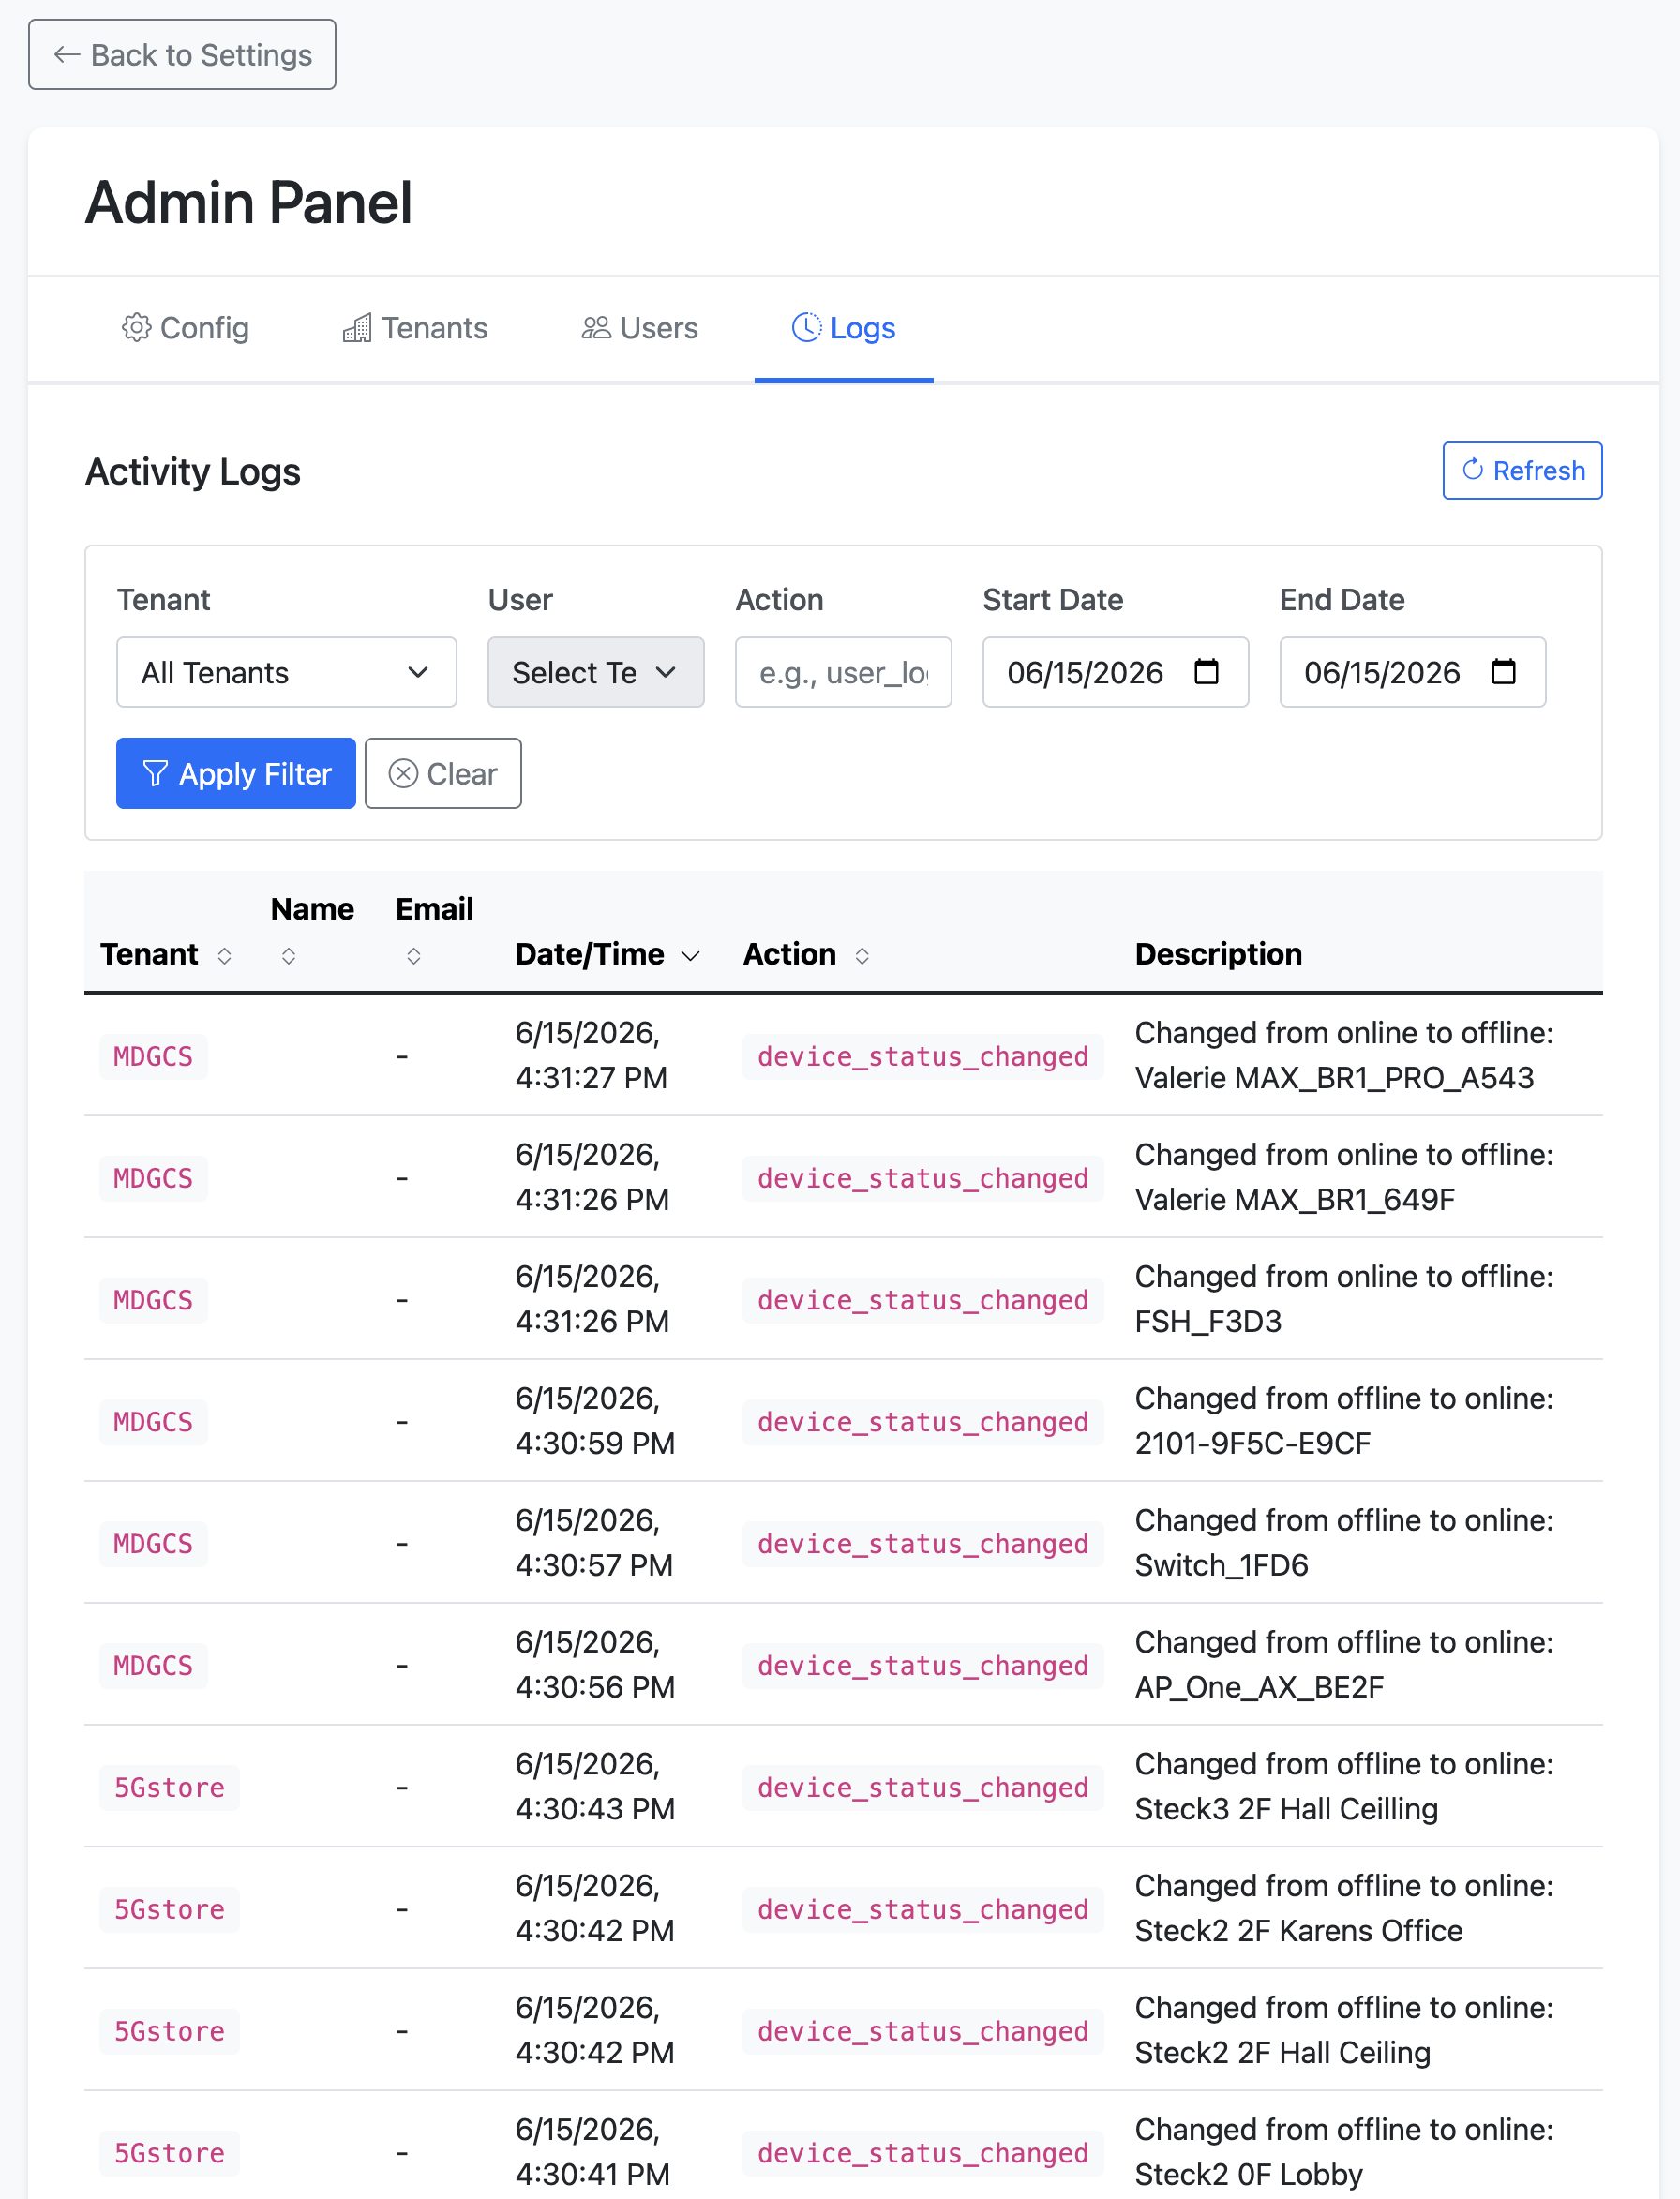
Figure: Admin Panel: cross-tenant activity logs.

8. Hardware Network Monitor (Coming Soon)
The Hardware Network Monitor is an optional plug-in appliance for your problem sites. RouterStatus tells you the status of your routers; the Hardware Network Monitor goes deeper at a specific location — watching the whole network from the inside and keeping a full history over time, so you can see exactly what happened, and when. It is a completely optional add-on and is coming soon.
How it connects. Once a Hardware Network Monitor is deployed at a site, the device it is attached to shows a small pulse icon on its card in the RouterStatus dashboard. Click that icon to open the monitor's own dashboard for a live, in-depth view of that location.
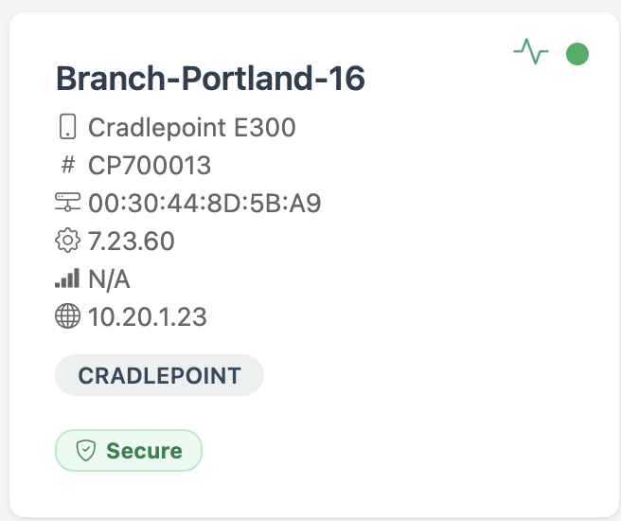
Figure: A device in RouterStatus with the pulse icon (top-right) that links to its Hardware Network Monitor.

8.1 At-a-glance overview
The monitor's overview summarizes the site in real time: live download, upload, latency, jitter, and packet loss (each compared against its recent average), the number of devices online, VoIP call quality, open security findings, active alerts, and UPS power status. On-demand actions let you trigger a speed test, VoIP test, WiFi scan, security audit, or port scan at any time.
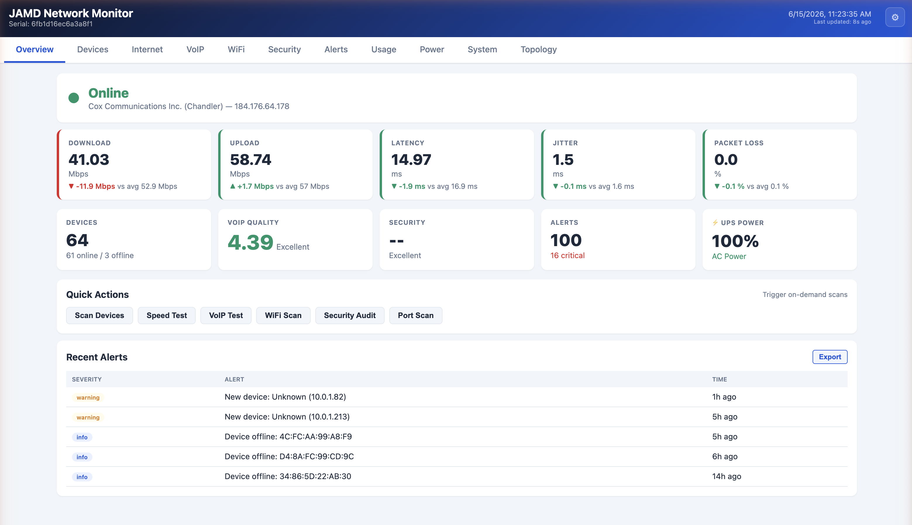
Figure: Overview: live performance, device count, VoIP quality, alerts, and UPS power at a glance.

8.2 What it tracks
Every metric is recorded over time, so you get trends and history rather than just a snapshot. Capabilities include:
- Internet performance over time — automated upload and download speed tests, latency, jitter, and packet loss, charted across Today, 24 hours, 7 days, and 30 days, with a full test log and per-server results.
- Cloud and QoS testing — latency to major cloud providers (AWS, Azure, Google Cloud, Cloudflare) and DSCP/QoS validation to confirm the router and ISP honor voice and video traffic priority.
- WiFi scanning and best-channel recommendation — discovers nearby access points across 2.4 GHz and 5 GHz, flags congestion and rogue or open networks, and recommends the cleanest channel to use.
- VoIP quality and testing — continuous MOS call-quality scoring with latency, jitter, packet loss, NAT type, and SIP ALG detection, plus on-demand VoIP and SIP ALG tests.
- Power and UPS monitoring — tracks whether the site is on utility power or battery, the battery charge remaining and estimated runtime, input voltage, and a history of power events (outages).
- Device discovery and count — finds every device on the local network, tracks how many are online over time, and alerts on new or unknown devices.
- Security and topology — a security audit (open ports, exposed services, encryption issues) and an auto-generated map of how the site is connected.
And more is on the way. A few of these views are shown below.
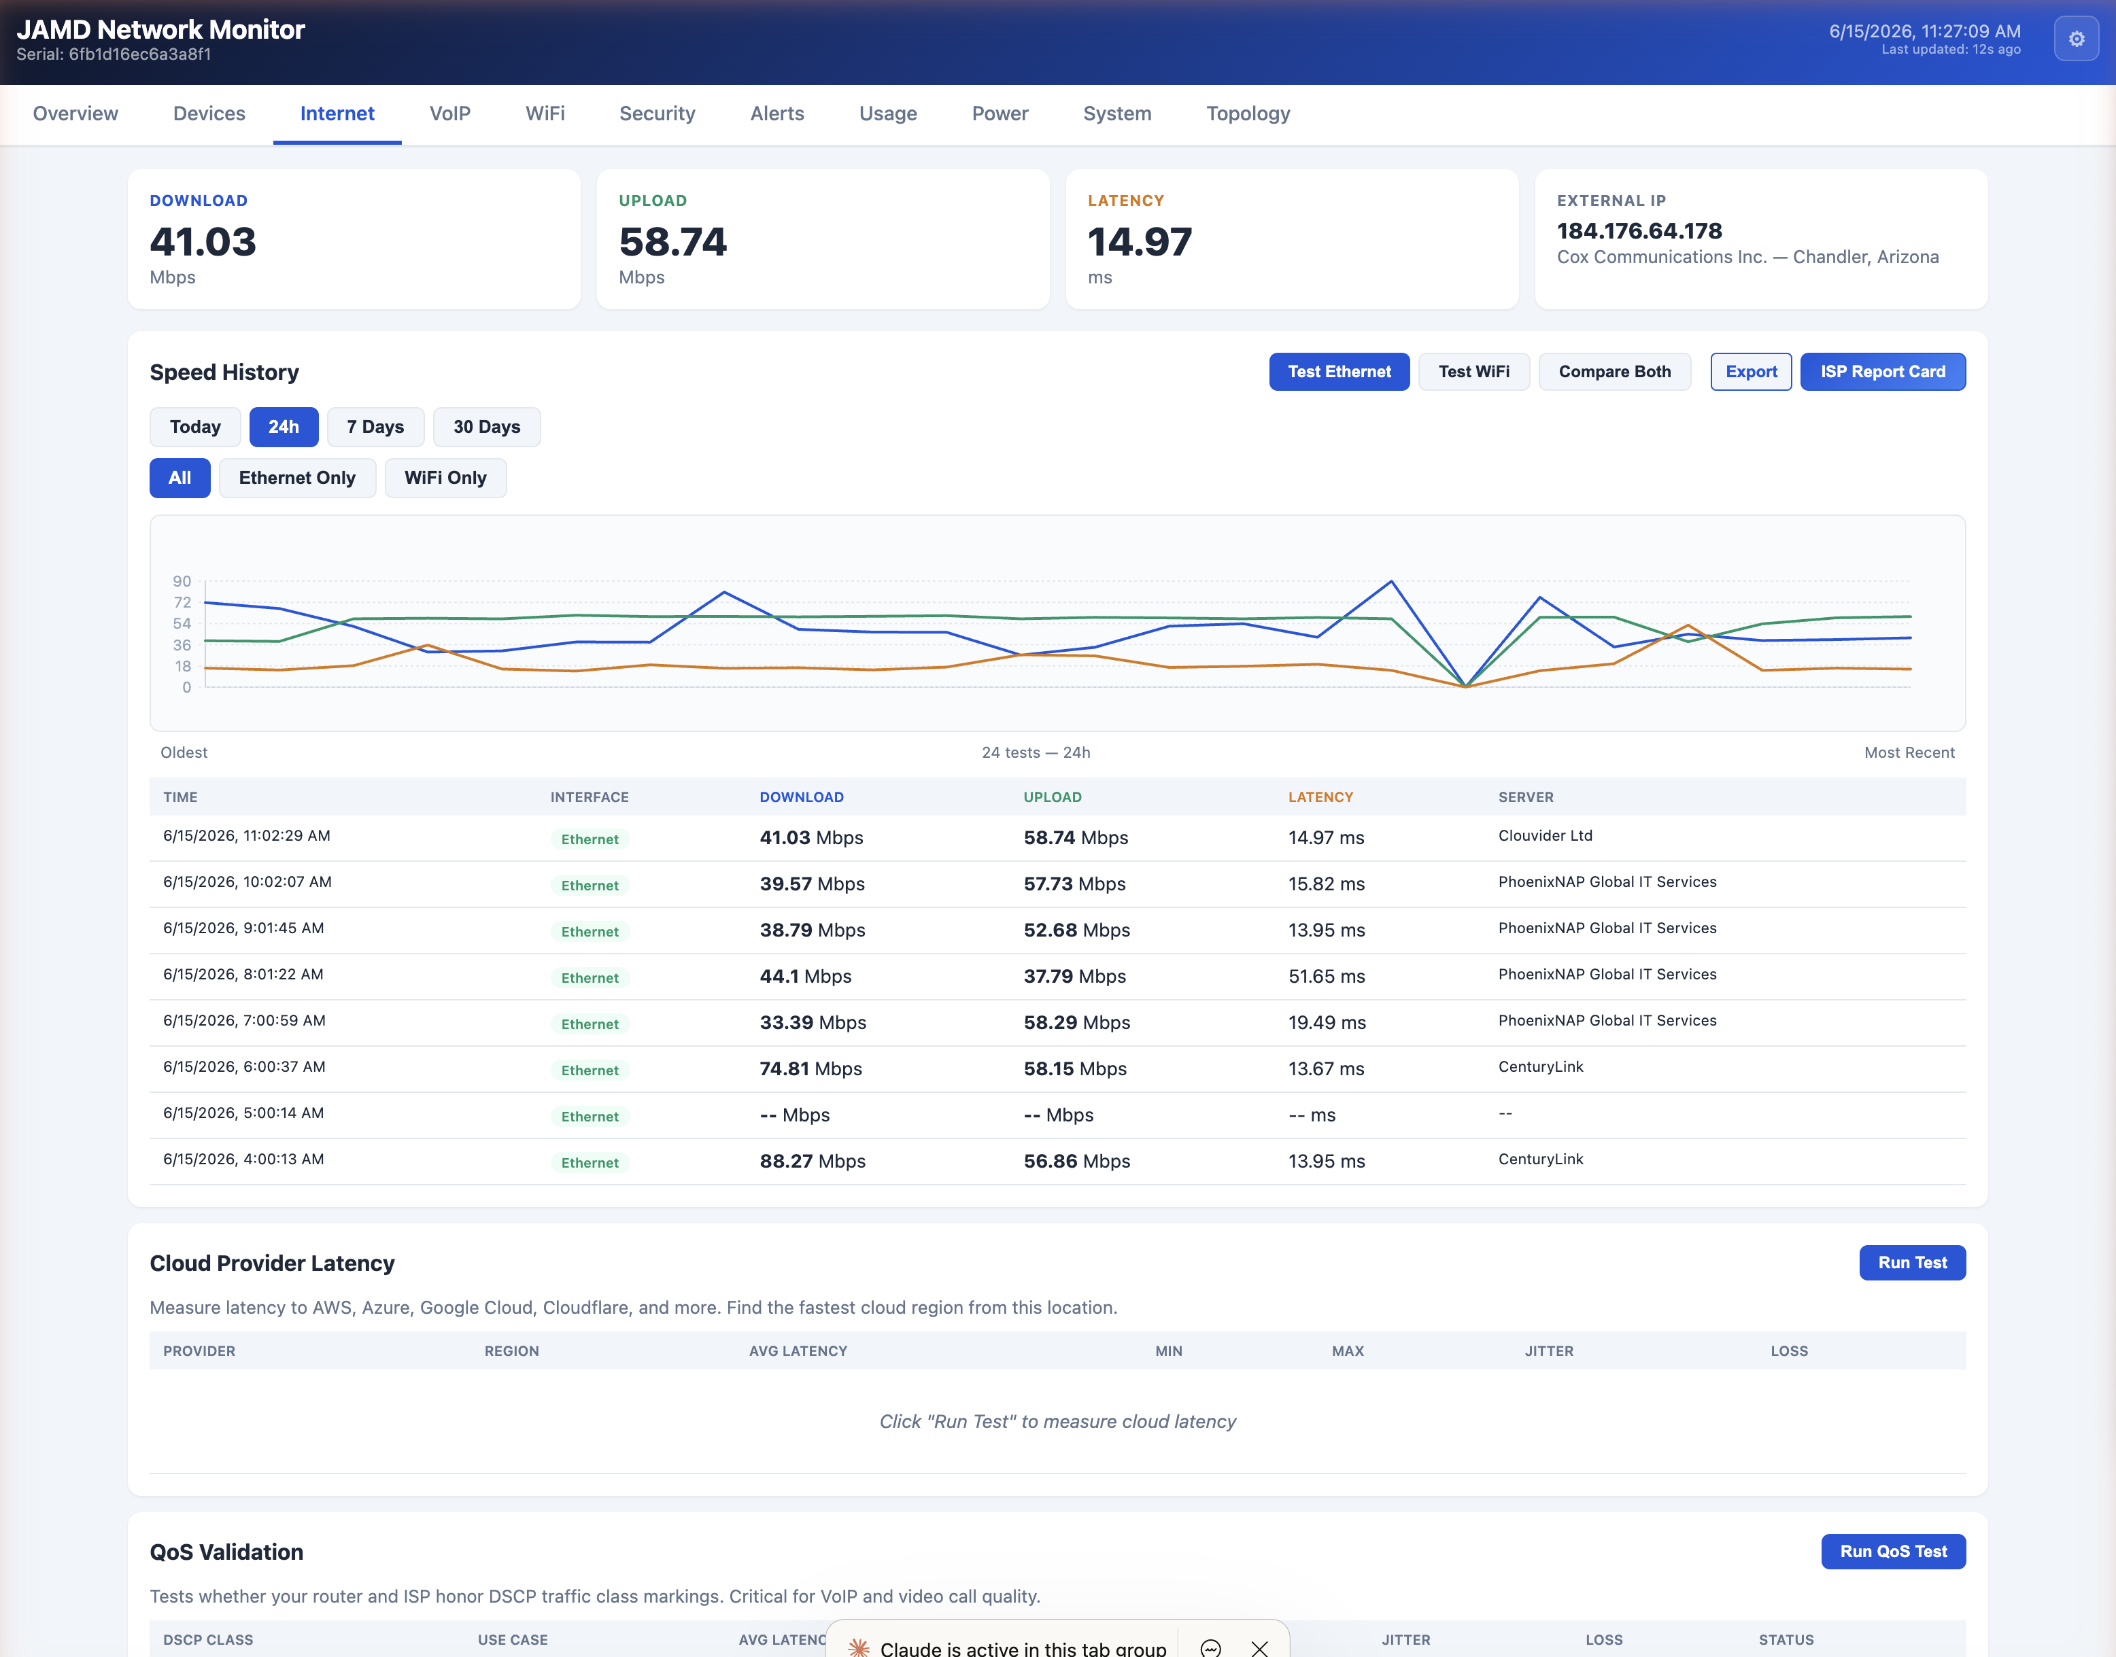
Figure: Internet: upload, download, and latency history with a full speed-test log.
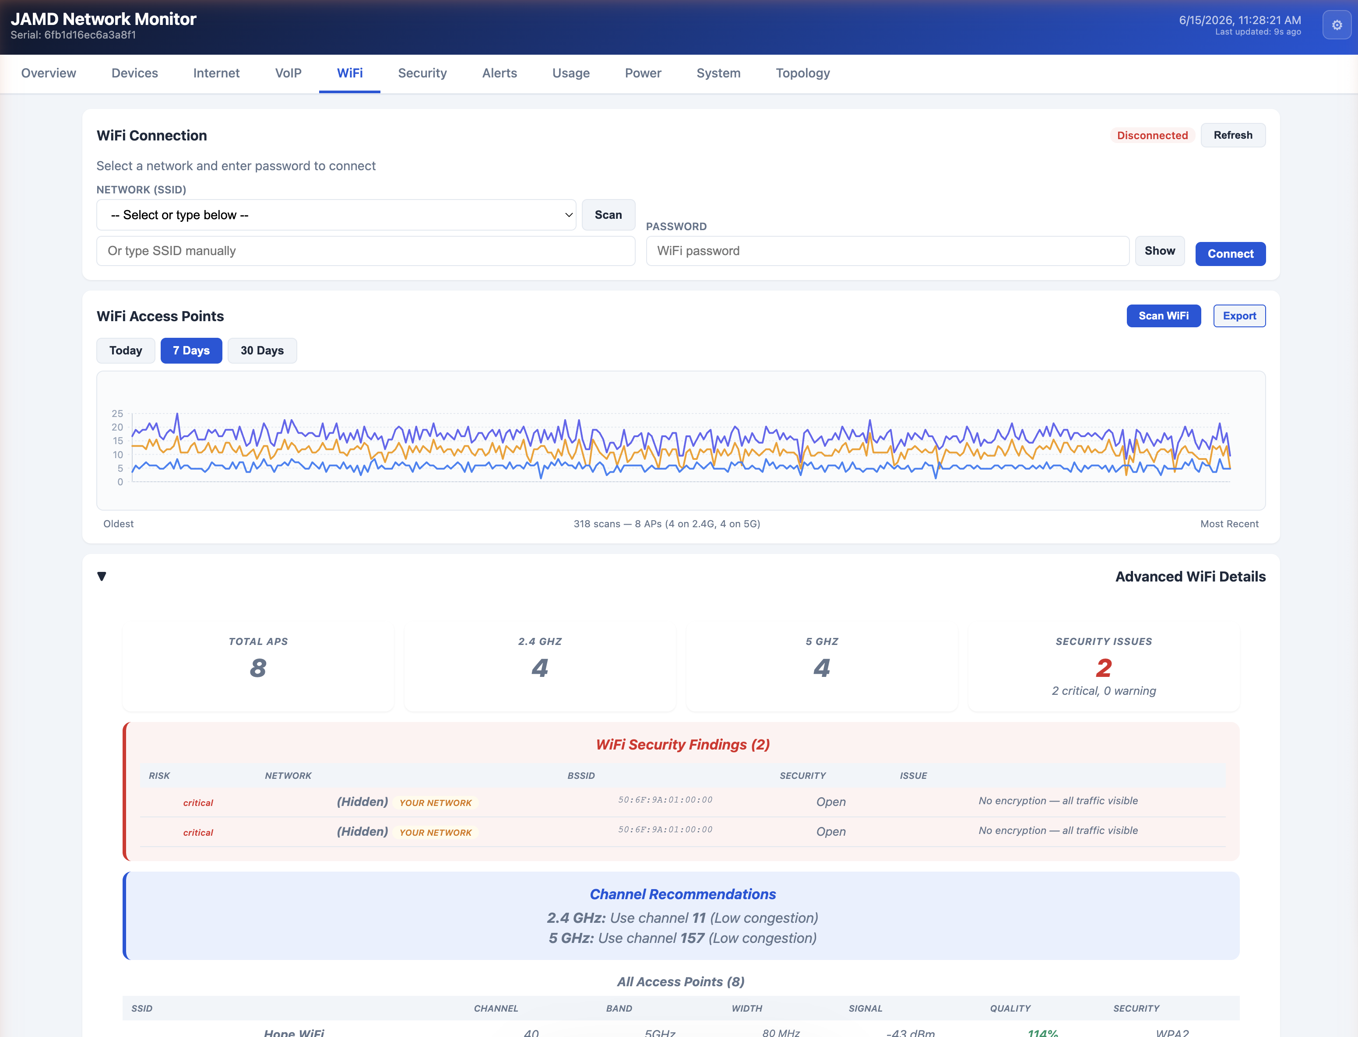
Figure: WiFi: access-point scan with congestion analysis and a best-channel recommendation.
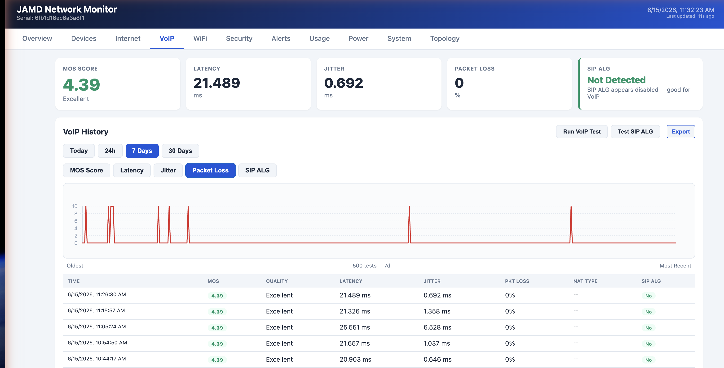
Figure: VoIP: MOS call-quality scoring, jitter and packet-loss history, and SIP ALG detection.
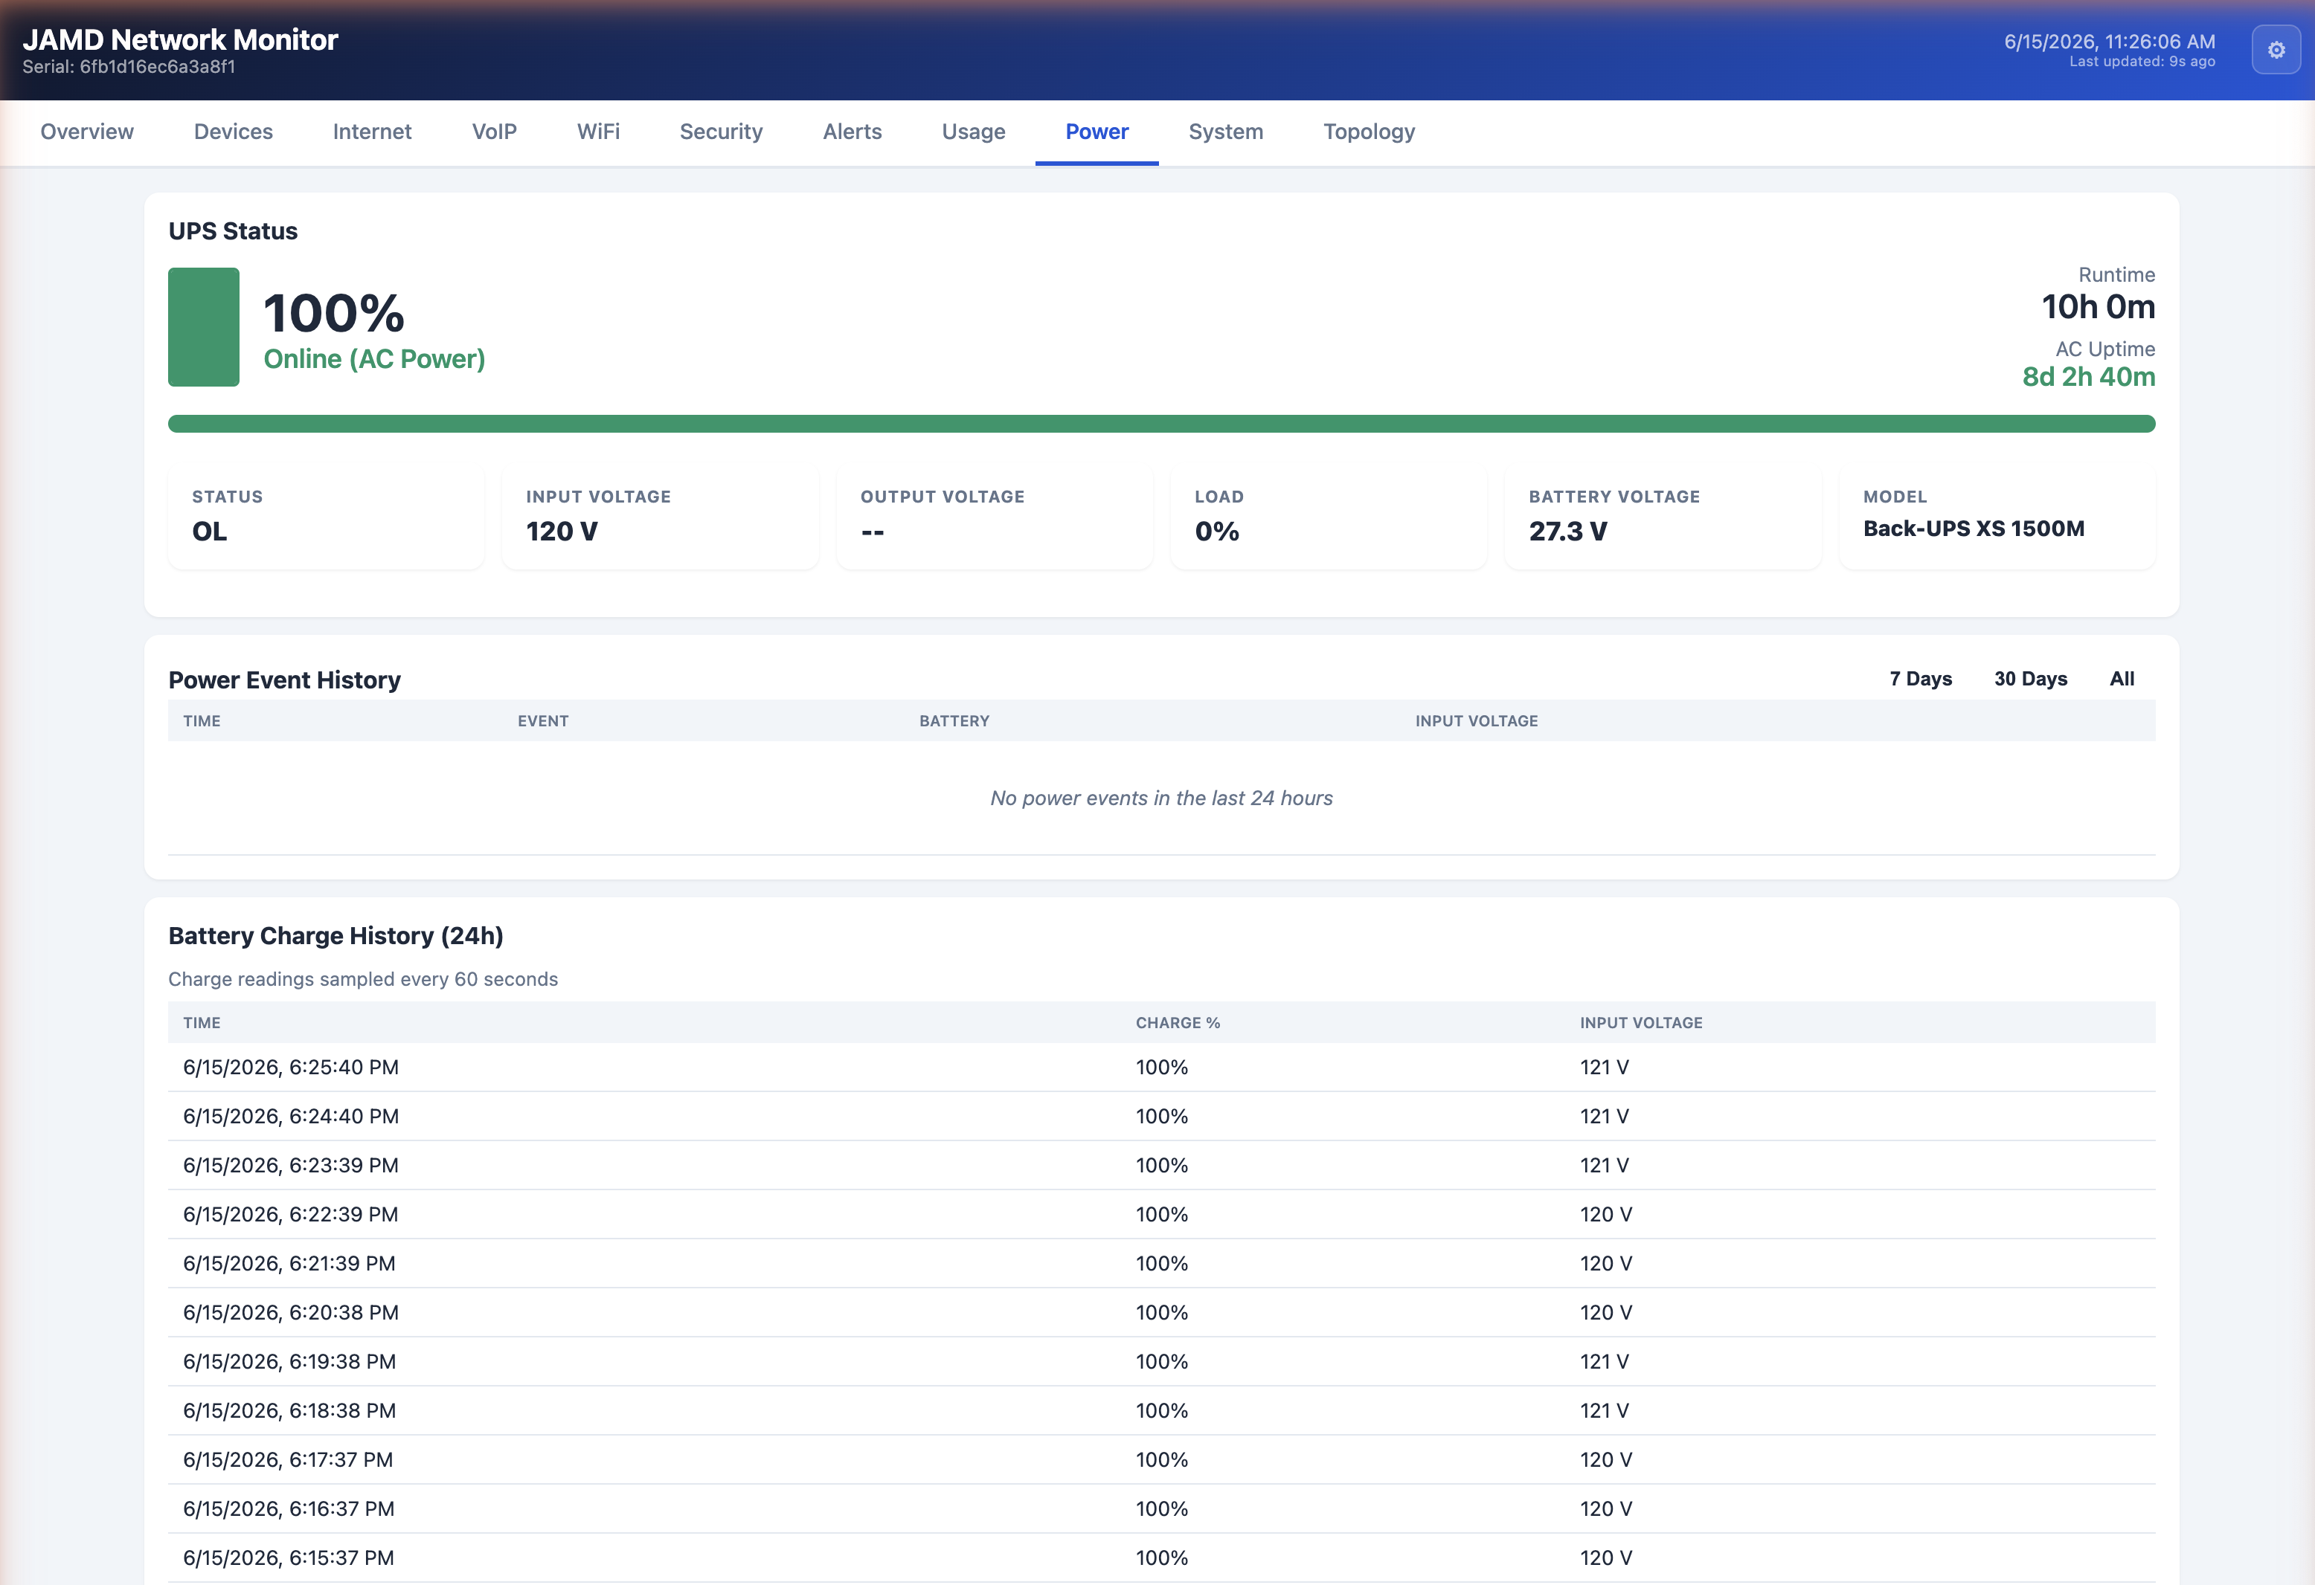
Figure: Power: UPS status, battery charge and runtime, and a power-event history.

8.3 Settings and scheduling
The monitor is configurable from its Settings page (the gear icon, top-right). Key controls include:
- Test Schedule — choose how often tests run and how much data the monitor uses: Unlimited (hourly tests), Ramp Down (intensive at first, then relaxed), Low Data, or Ping Only. Each mode shows an estimated monthly data usage, so it can be tuned for metered or limited-bandwidth sites.
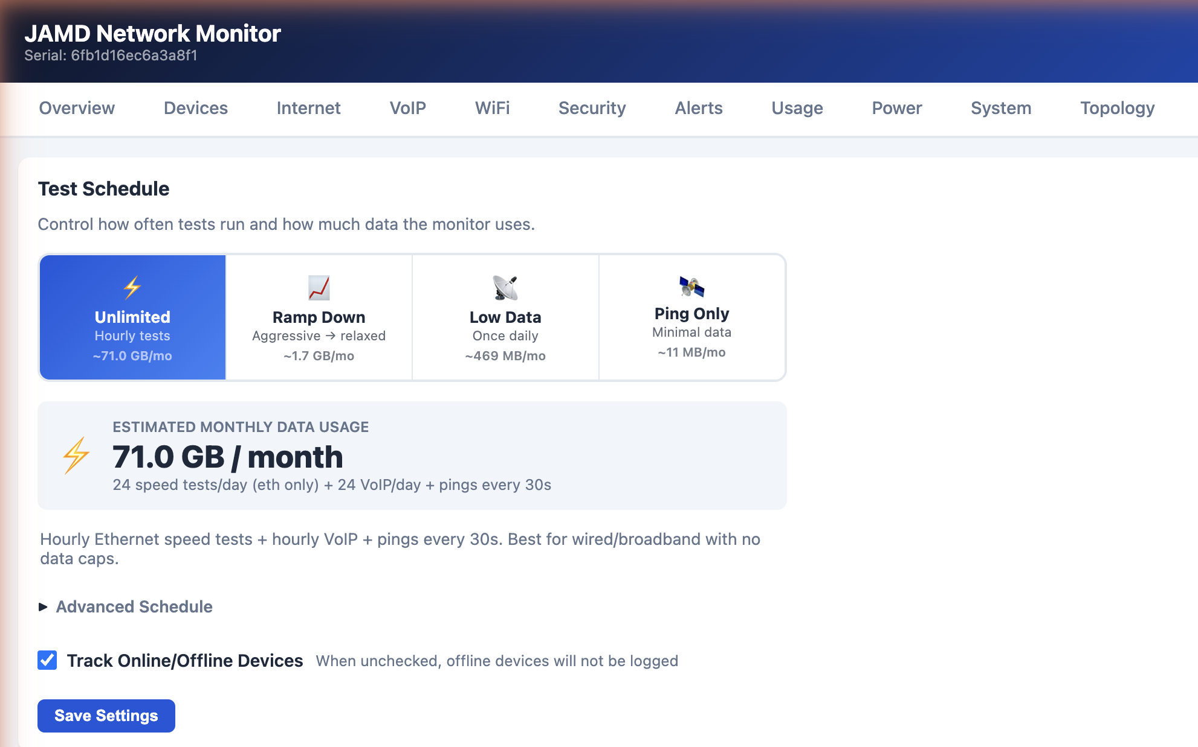
Figure: Settings: Test Schedule data modes with estimated monthly usage.
- Alert Logging Frequency — throttle how often each alert type is logged (every occurrence, once per hour, or once per day) to prevent alert fatigue when the same issue keeps firing.
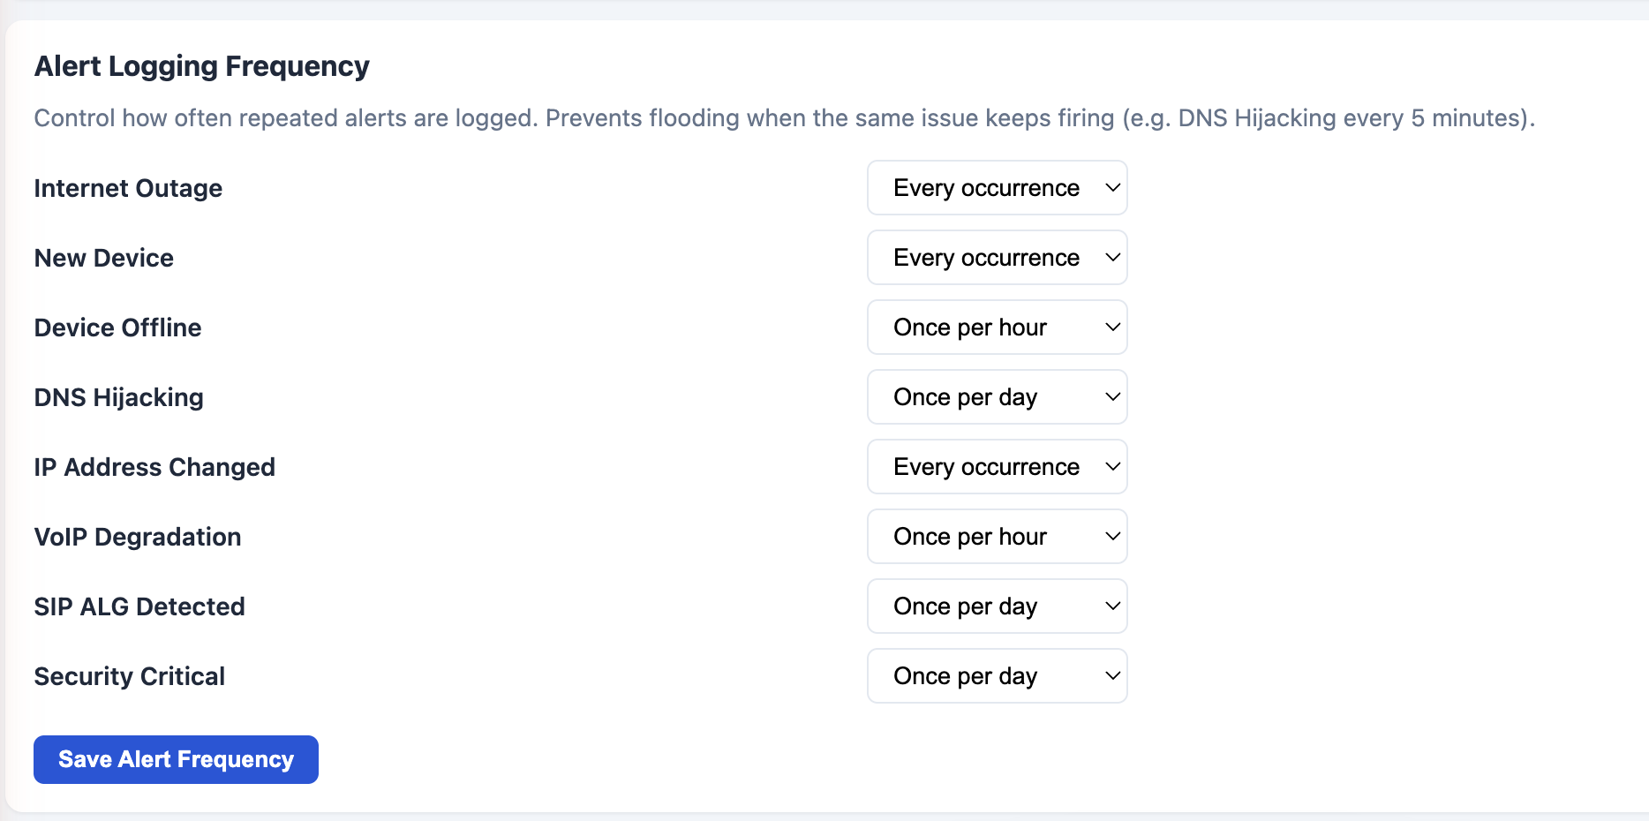
Figure: Settings: per-alert logging frequency.
- Backup Connection — designate a secondary interface (USB Ethernet or WiFi) so the monitor can still send “Internet Down” and “Internet Restored” emails when the primary connection fails.
- Approved Devices (Whitelist) — maintain a list of trusted MAC addresses; anything not on the list triggers a Rogue Device alert. WiFi credentials can also be saved here so they persist across reboots.
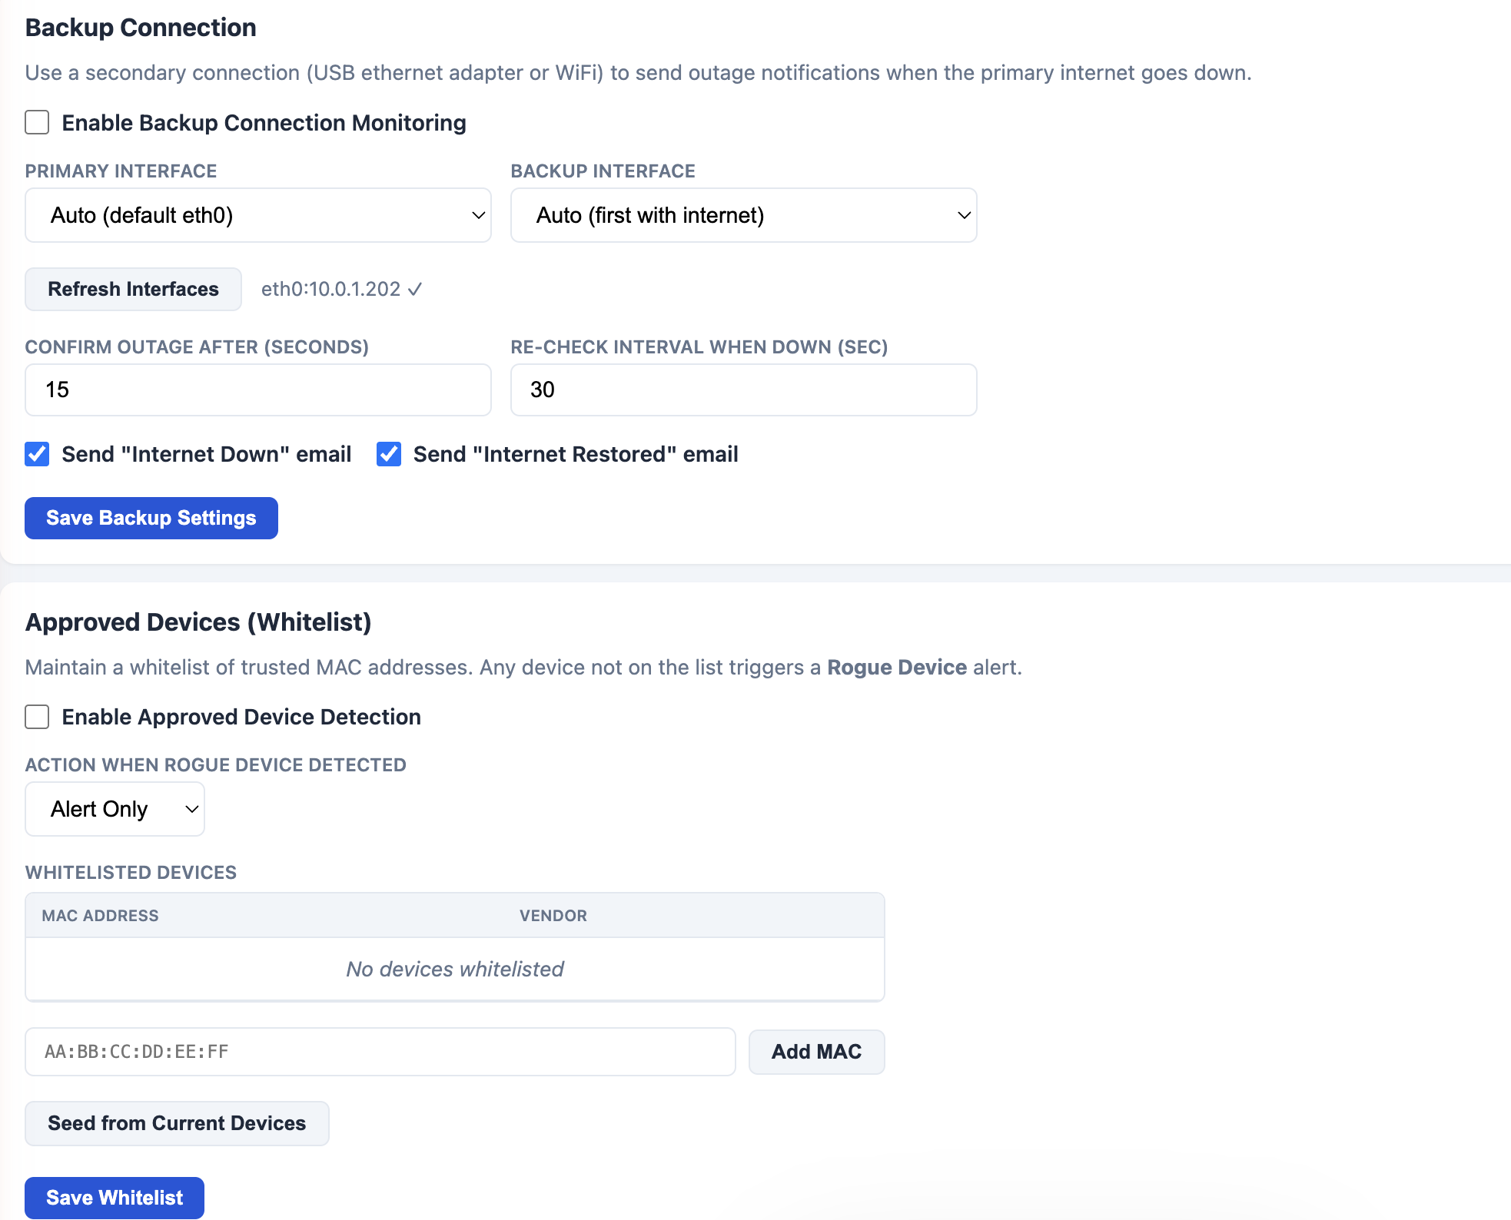
Figure: Settings: Backup Connection and the approved-device whitelist.
Note: The Hardware Network Monitor is an optional add-on and is coming soon. Contact RouterStatus to learn about early access or to add it to a problem site.

Appendix A. Credential Quick Reference
Where to obtain each vendor's API credentials. See Section 5 for full step-by-step instructions.
Vendor | Platform / URL | Credentials needed
CradlePoint | NetCloud Manager — cradlepointecm.com | X-ECM-API-ID, X-ECM-API-KEY, X-CP-API-ID, X-CP-API-KEY
Peplink | InControl 2 — incontrol2.peplink.com | Client ID, Client Secret, Organization ID
Teltonika | RMS — rms.teltonika-networks.com | API Key (Personal Access Token; requires 2FA)
Semtech / Sierra Wireless | AirVantage / ALMS — na. or eu.airvantage.net | Client ID, Secret Key
Digi | Digi Remote Manager — remotemanager.digi.com | API Key ID, API Key Secret
Inseego | Inseego Connect — connect-api.inseego.com | Subscription Key, Tenant Name, Application Name

Note: Some vendor portals reveal the secret half of a credential only once, at creation (Cradlepoint, Digi, Sierra Wireless). Always copy and store secrets before closing the dialog. Generating API keys typically requires an administrator account on the vendor platform.

